

# 

# 

# **General Rules:**

* Math expression

for each **lim** or **fraction** expression applied will decrease current no. of lines by one.

any element has only one line **lim** and **fraction** are not allowed.

ex. of elements has one line:

* titles
* drag & drop elements in quiz complete questions
* drag & drop elements in quiz venn questions
* match elements in quiz
* complete timeline in quiz

for rest same rules are valid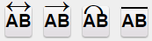

.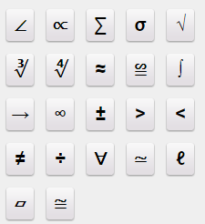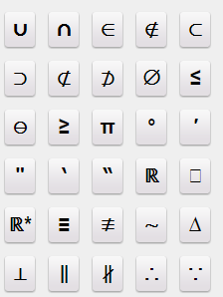

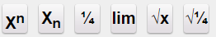

* any text input within text count as 3 words
* plugin main title max 7 words
* all input - complete in quiz or activity ...etc - can’t have any special char or math expression

# 

# 

# **ld Templates**

## ***Flipping cards***

* Put intro sound, during playing it cards will be appear (optional).
* Cards limitation from 2 to 5 card.
* Every card has 2 faces (text or image).
* Screen main title (Must).
* Help text (Must).
* Intro text two lines max 8 words and 5 character per word (optional)
* Maximum words in each card is :
  + 21 word in case 2 cards (7 lines * 3 words).
  + 14 word in case 3 cards (7 lines * 2 words).
  + 14 word in case 4 cards (7 lines * 2 words).
  + 7 word in case 5 cards (7 lines * 1 words).
* Images can have text



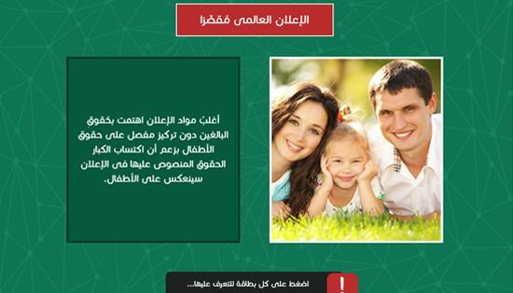

## ***Hot spot***

* Put intro sound (optional).
* This Template display maps with spots on it at least one spot.
* Click on each spot display (text or image) with sound narration.
* No Screen title at all.
* Help text.
* spot must have text or image
* spot text of 20 word - of max 8 lines -
* Images can have text

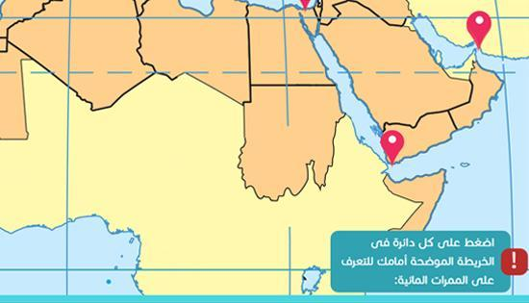

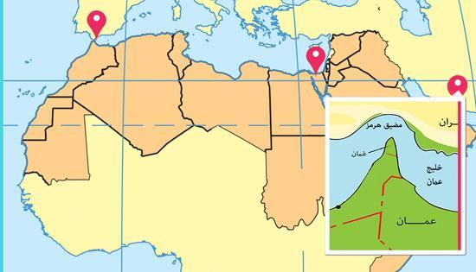

## ***Infographs***

* This Template display expression and its related factors in show looks like the expression in the center and branches surround it.
* Should determine the sequence of showing factors and turn into another one.
* Sound narration [(Must).
* Images with SVG extension (Must) - vector shapes only no images included -.

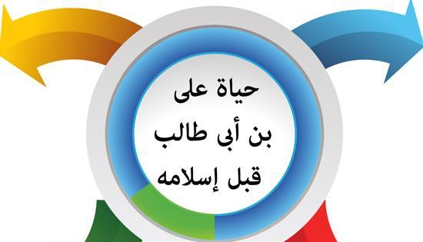

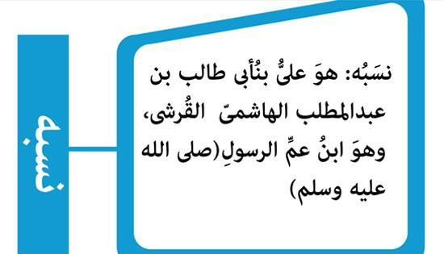

## 

## ***Time line***

* Screen main title (Must).
* Contain icons from (2 to 5).
* During sound intro icons appears (optional).
* Each icons has sound narration (optional), at least one text and one image (Must) or video.
* icon title of max 3 words
* icon description of max 50 word ( 8 lines ) - the more lines added the less space for image -

so we recommend max 3 lines.

* Images can have text

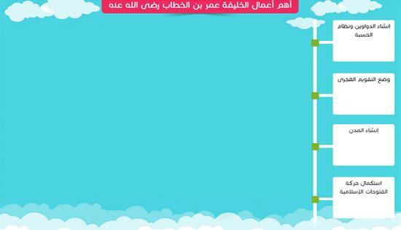

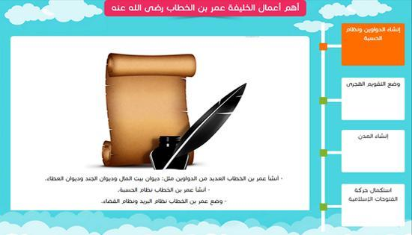

## ***Dictionary***

upto 4 types ex:

(Word + definition), (word +opposite), (word + single), (word + plural).

type titles of max 2 words.

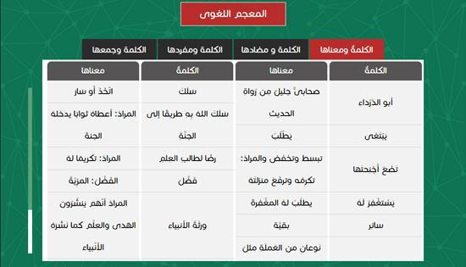

## 

## 

## ***Glossary***

* Display the glossary of lesson or unit.
* Screen main title (Must).
* Each expression contain the expression itself and its definition (Must), may be contain image, sound, or both (optional).
* definition title of max 2 words

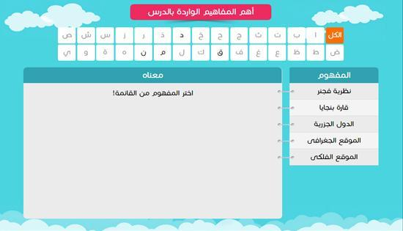

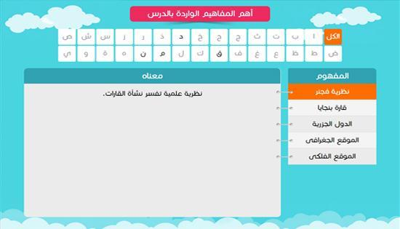

## ***Slideshow***

* Template contain many slides with image, text and sound.
* Sound narration playing until the end of slide show (Must).
* Each part contain Image (Must).
* Text with each part below the image (optional).
* Play and pause the slideshow by clicking on any part of the slideshow.
* Synchronize image, text and sound with each other.
* Manage the total time of slide show with all slides wisely.
* the more lines added the less space for image - so we recommend max 3 lines
* Title : of max 5 words - one line.
* Images can have text



## 

## 

## ***Static screen***

* Template contain many pages; navigate between them by next and previous buttons.
* Sound narration (Must).
* Synchronize each sound with one image or more.
* Screen main title (Must).
* Synchronize sound, image and text displayed.
* Maximum words in each page 35 word (8 lines).
* Text is a must
* Images can have text

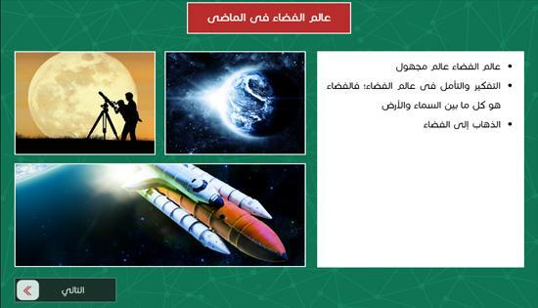

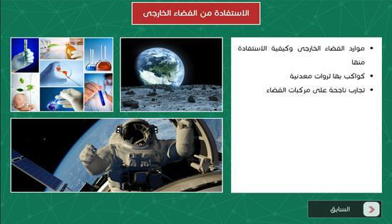

***Flowchart***

* Template display the lesson element and branches of each one.
* Put intro sound (**Must**).
* Screen main title (Must).
* Element title (optional or put the main title instead of it).
* Title of sub branch (Must).
* Sound of each branch (optional).
* Text, image or both for each branch.
* The base of chart has from 2 – 4 branch.
* Each branch can contain from 1 – 4 sub branch.
* Each title in 2nd or 3rd branch Must contain maximum form 3 word.
* text in last level - 10 lines of max 5 words per line if no image - if there is an images max 3 lines with 5 words per line -
* Vertical flow chart Images can have text
* Horizontal flow chart Images can’t have text
* Can add video or images

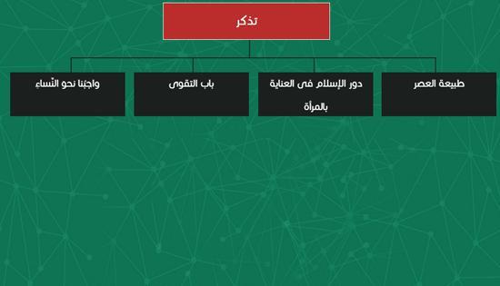

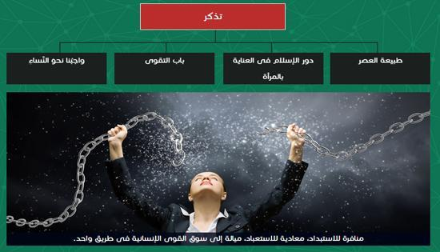

**Crossword**

* Template display crossword activity.
* Screen main title (Must).
* The maximum number of letter is 8 (Must).
* Sound with true or wrong answer, can add another sound (optional).
* At least contain one word (Must) and max of 5 words.

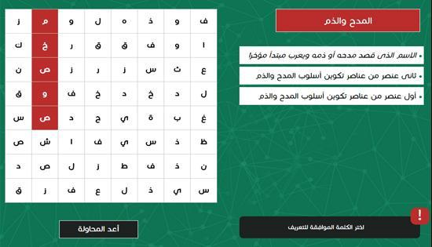

## ***Sequence***

* Sound narration with many square appear (optional).
* Squares from 2 to 6.
* Click on each square display popup contain (text, image or both or video) and sound narration (optional).
* Screen main title (Must).
* Help text (Must).
* **Arrows are optional to display**
* popup text of max 70 words - max of 8 lines -
* Images can have text
* Can add video or image

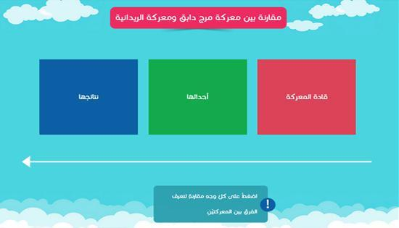

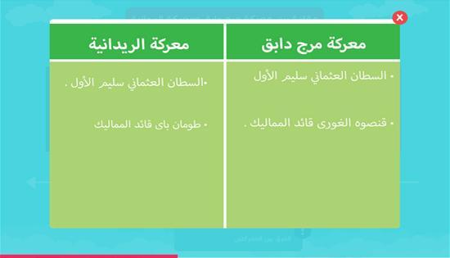

## ***Tabs***

* Tabs from 2 to 5.
* Each tab contain text & image (Must).
* Images can be more than one image so it can displayed as slideshow but text entered once and cannot be changed.
* Each tab with sound narration (optional).
* Maximum number of words is 40(8 lines).
* tab title of max 3 words
* Images can have text

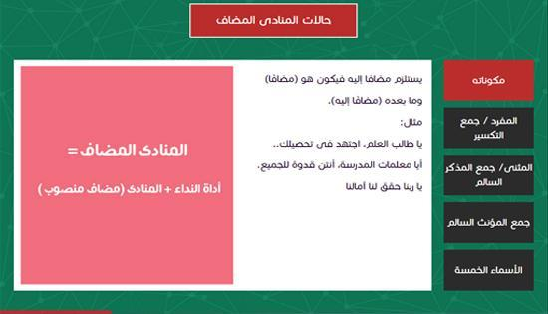

# 

# 

# ***Science Templates***

## ***Progress***

* It contain from **2 to 8 nodes**
* First and last node can have **max 60 chars - 8 words -**
* Other nodes can have **80 chars - 10 words -**
* Links between nodes can have **18 chars - 2 words most -**
* You can click on each node except first node to open pop up window
* Pop up window can have
  + Text - **max 10 lines , with max 8 words per line -**
  + Media [ images or video ]
* Images can have text

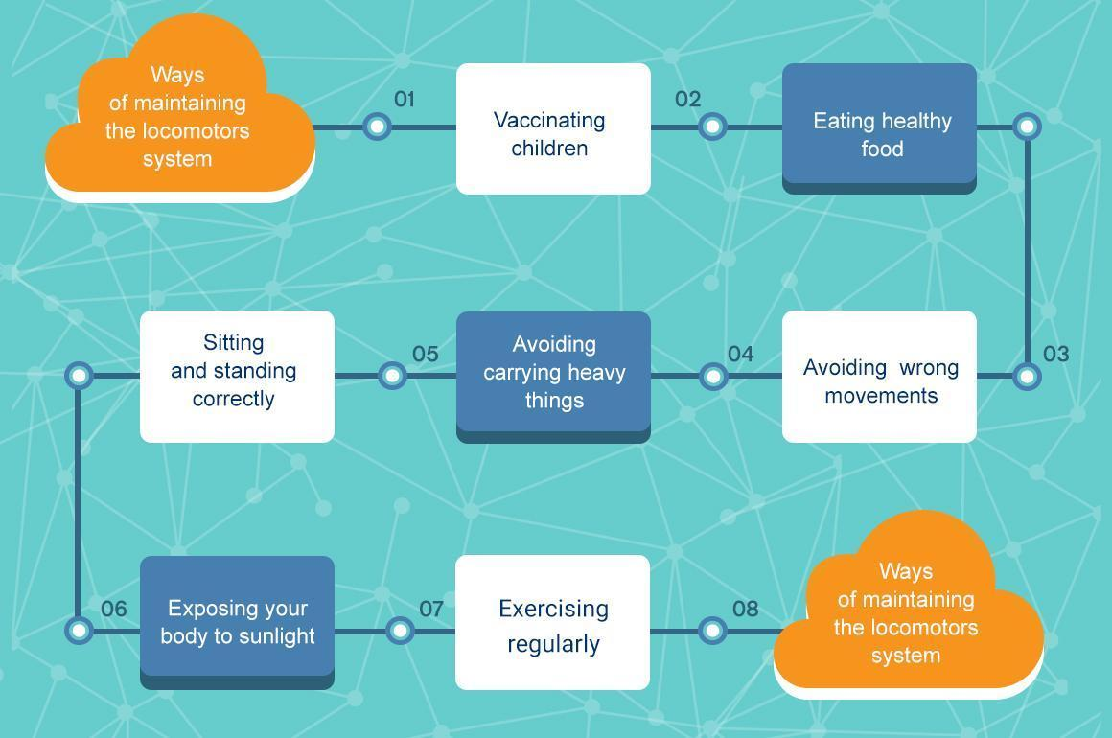

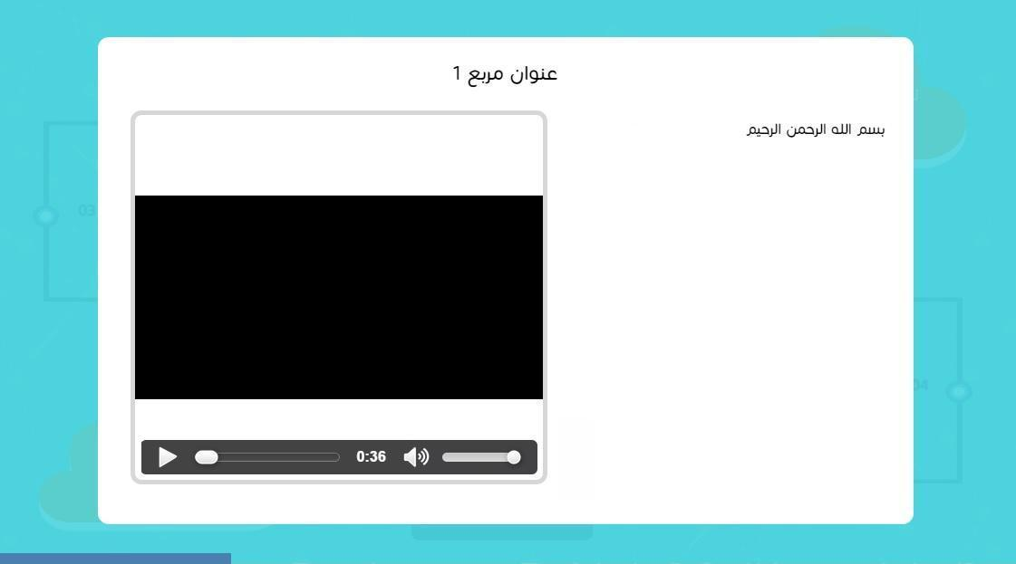

## ***Comparison***

Can compare between **2 , 3 and 4 elements** with **max 5 points of comparison**

Points of comparison **8 words max of 64 chars**

Images can’t have text

### **Vertical layout:**

If compare between **2 elements**

Title max **40 chars**

With image max text per element **4 lines - max 5 words** per line -

Without image max text per element **9 lines - max 5 words** per line -

If compare between **3 elements**

* title max **25 chars**
* with image max text per element **4 lines - max 3 words** per line -
* without image max text per element **9 lines - max 3 words** per line -

If compare between **4 elements**

* title max **20 chars**
* with image max text per element **4 lines - max 2 words** per line -
* without image max text per element **9 lines - max 2 words** per line -

### **Horizontal layout:**

If compare between **2 elements**

* title max **40 chars**
* with image max text per element **4 lines - max 6 words** per line -
* without image max text per element **4 lines - max 8 words** per line -

If compare between **3 elements**

* title max **25 chars**
* with image max text per element **4 lines - max 5 words** per line -
* without image max text per element **4 lines - max 8 words** per line -

If compare between **4 elements**

* title max **20 chars**
* with image max text per element **3 lines - max 5 words** per line -
* without image max text per element **3 lines - max 8 words** per line -

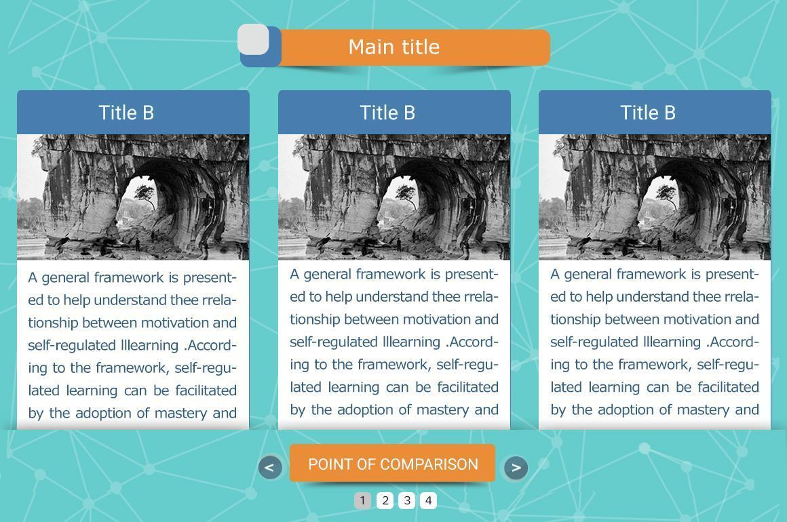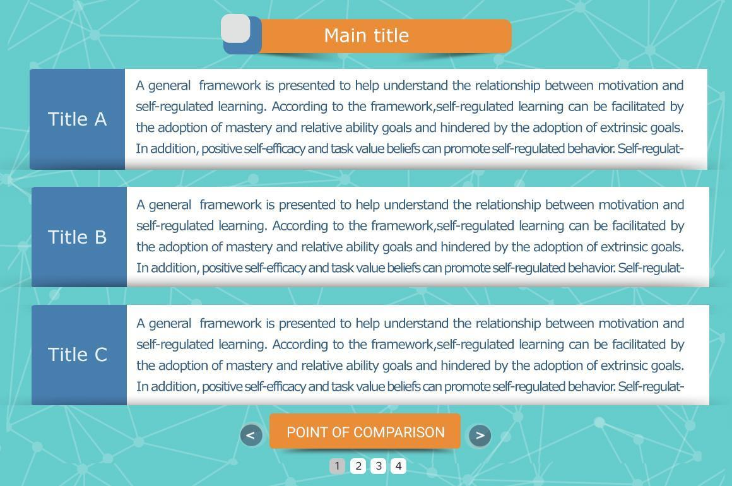

## ***Drag & Drop***

* Draggable element up to 6 elements
* **One to one relation** - droppable area hold one and only one draggable element -
* draggable element count must equal to droppable elements count.
* Text in title of element **max 3 words**
* Images can’t have text

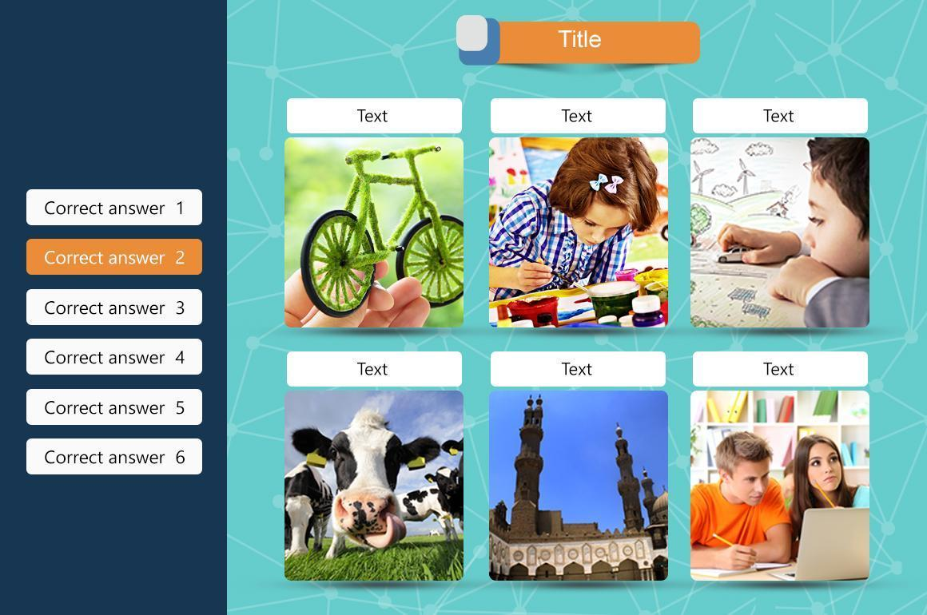

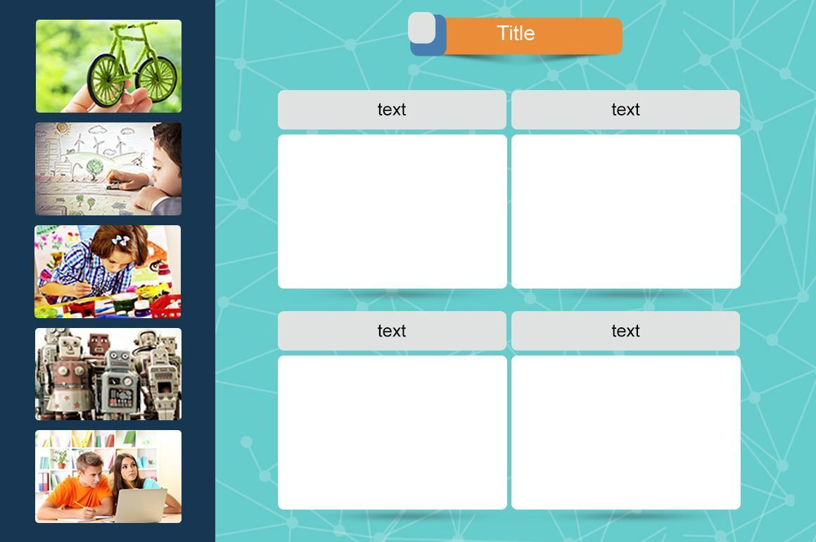

## ***Hotspot Area***

* **Only one portrait image.**
* Max 15 labels on image
* Label title text of max 2 words
* Label description text of max 20 words
* Help text of max 10 words.
* Images can’t have text

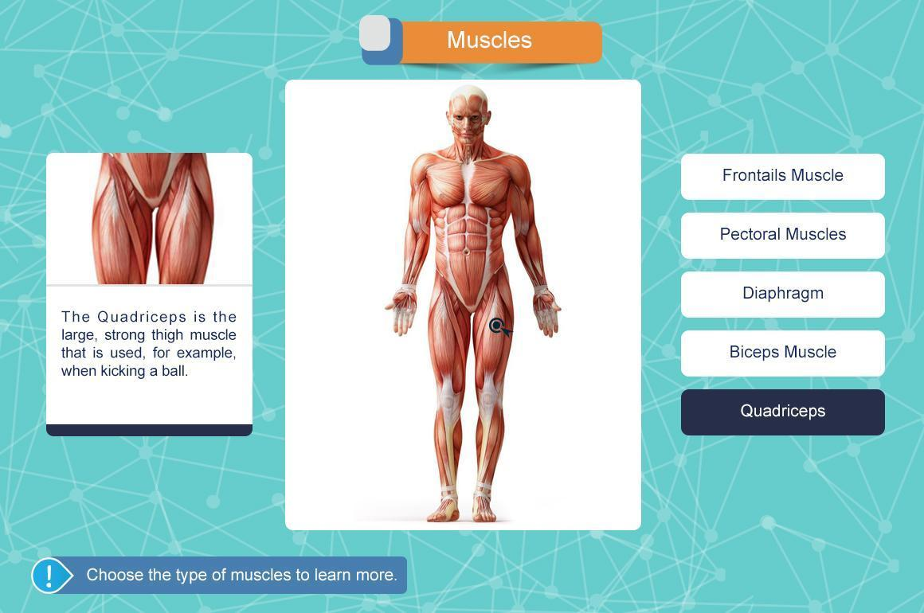

## ***Lab simulation***

* title of max 7 words
* **max 10** elements to drag on table each element is a step so max 10 steps - note from **5 elements** a scroll will appear -
  + count of steps equal to number of tools
  + each draggable element is equivalent to step
  + each step has
    - one image for draggable element
    - one image after drop element on table or a video for last step
    - text  - **max 2 lines , with max 10 words per line -**
    - sound when click in step btn
    - sound when drop element on table - no sound with last step if a video exist -
* **observation**  - **max 2 lines , with max 10 words per line -**
* **conclusion** text  - **max 7 lines , with max 10 words per line -** with note that only 1st 2 lines will appear first then click on arrow to expand for more.
* Images can’t have text

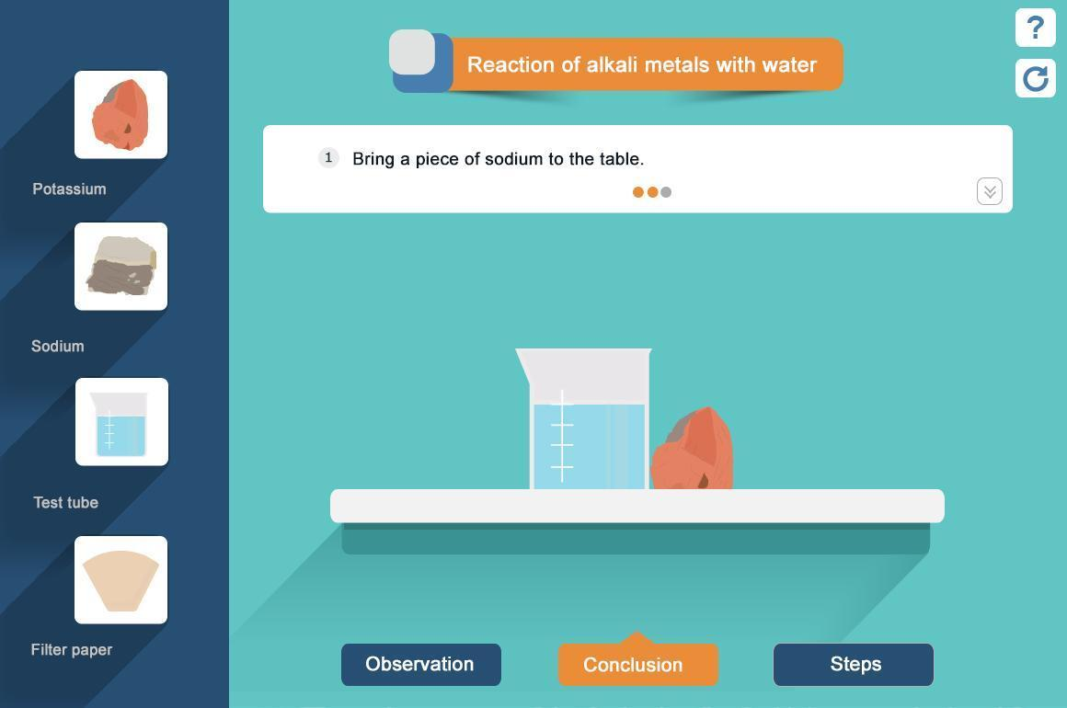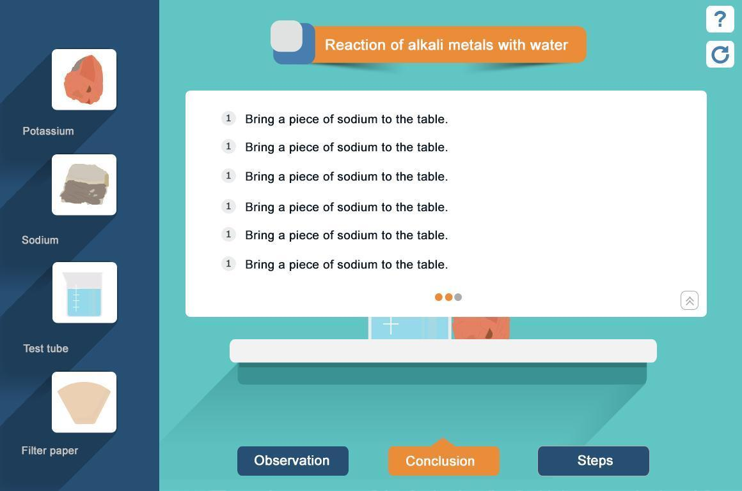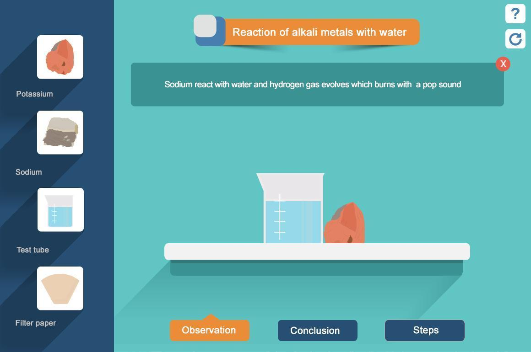

## ***MindMap***

Coloring by:

* level
* branch

First appear

* show first level only then click to expand for each nested level
* show all levels once without clicking

Only sound in last level

Nodes can contain text only with max 3 words in all level

After root can have up to 5 main branches with any nested levels on any count of children but

Help text up to 10 words

**Max count of nodes 15 nodes in all levels.**

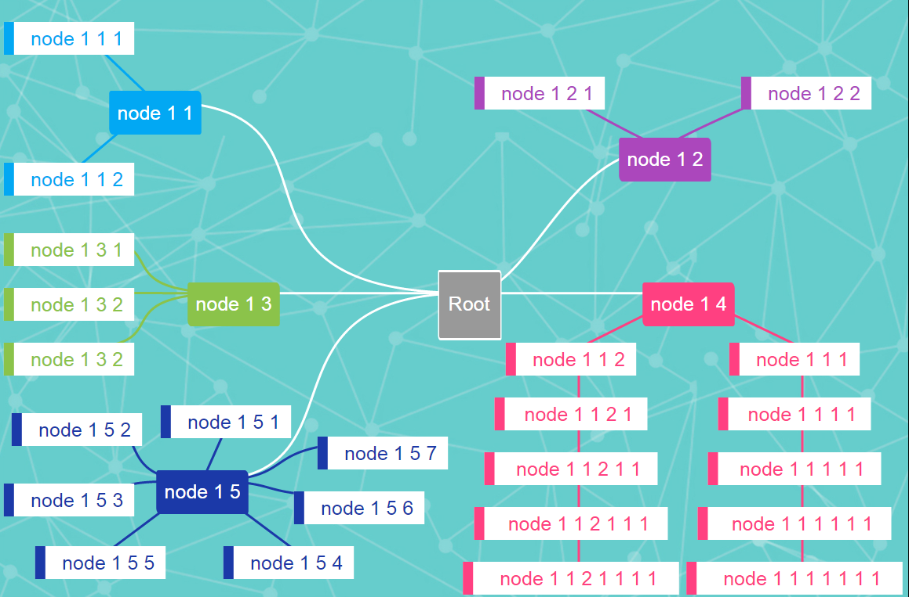

## ***Static Lab***

* text of max **8 lines - 5 words per line -**
* **Start button Text of max 5 words of (Optional)**
* **Intro sound (Optional)**
* **Icon Title max two words and 5 characters**
* **From 2:5 Icons**
* **Each icon have more than one tabs (Optional)**
* **Each tab can have sound with image or video(optional)**
* Images can have text

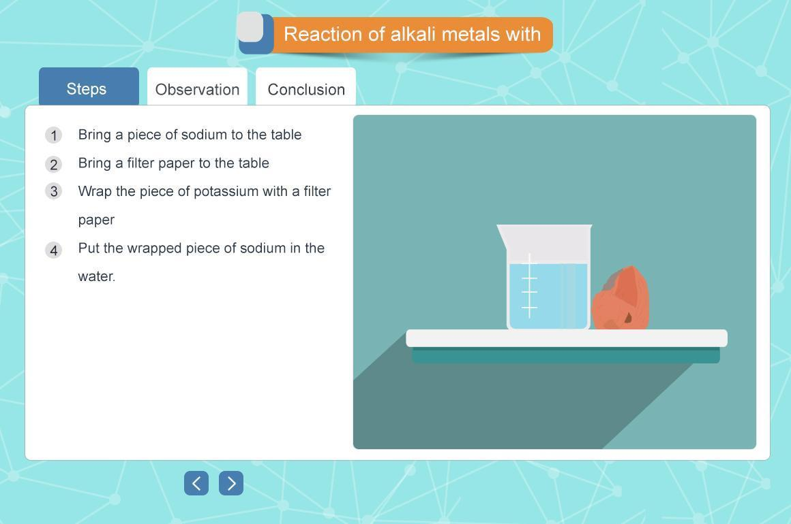

## ***Activity***

* type of available question [ single choice (one per page) - Multi choice- complete - true/false (one per page) ]
* question text : **max 2 lines - max 5 words per line -**
* Optional Feedback text in wrong and right answer: **max 2 lines - max 5 words per line -**
* Optional Feedback sound in wrong and right answer
* if no question text :**max 8 lines - max 5 words per line -**
* **Optional intro sound**
* **Each question can have video or images**
* in single choice question
  + max **4 lines of choices or max 4 option one line each**
  + can be **6 lines** if no conclusion
* Images can have text

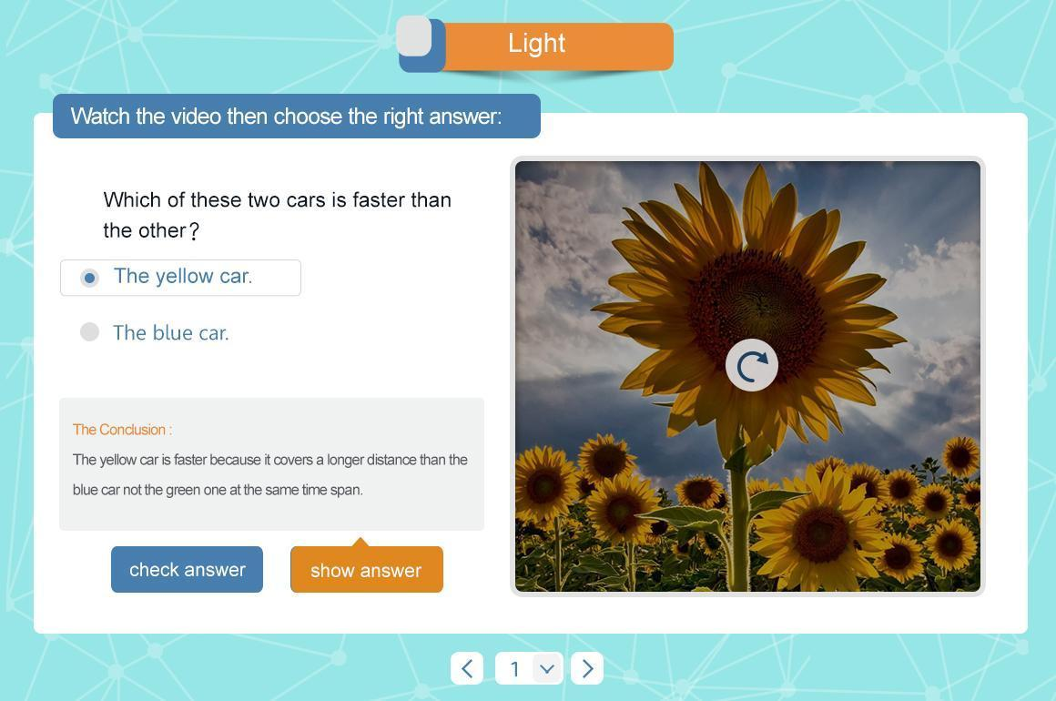

# 

# 

# ***Regular Quiz Templates***

## ***Complete***

* Complete Title: can accommodate up to 7 words.
* **complete text can have up to 7 lines - of max 10 words and input count as 3 words -**

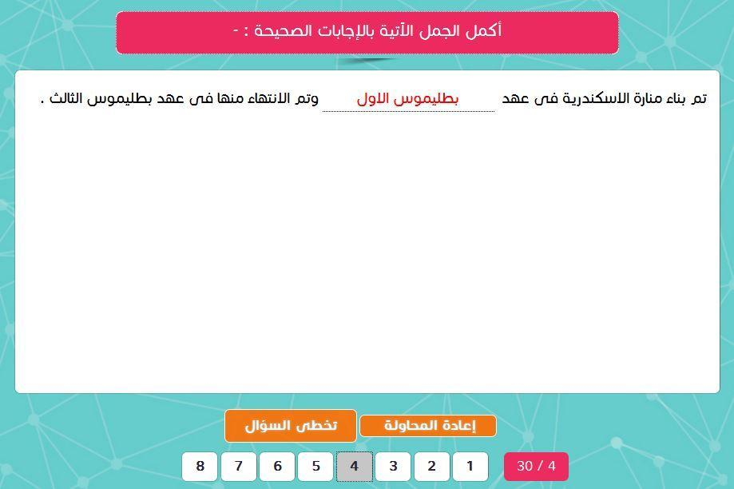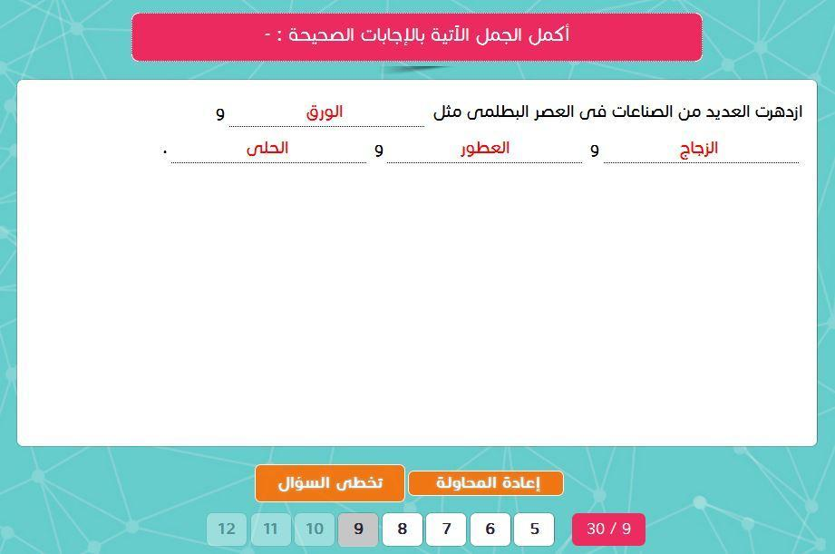

## 

## ***True or False***

Accommodates 8 lines and each line has 8 words only.

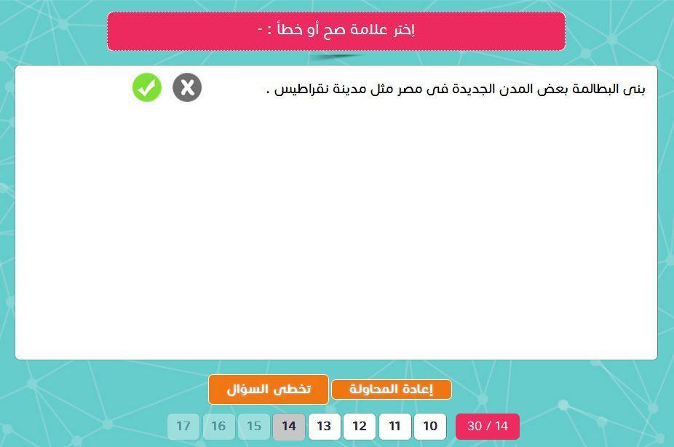

## 

## 

## ***Single Choice & Multiple choice***

Page can accommodate 8 lines and each line has 8 words only.

The maximum number of answers are 6 choices.  
Maximum of words in the answers are 5 words.

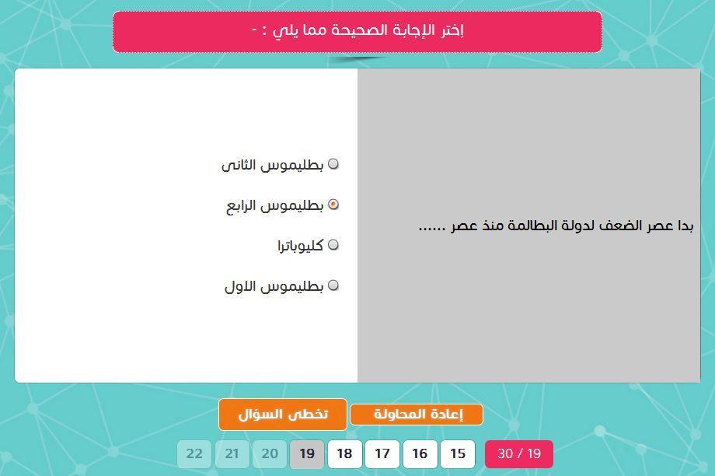

## 

## 

## ***Essay questions***

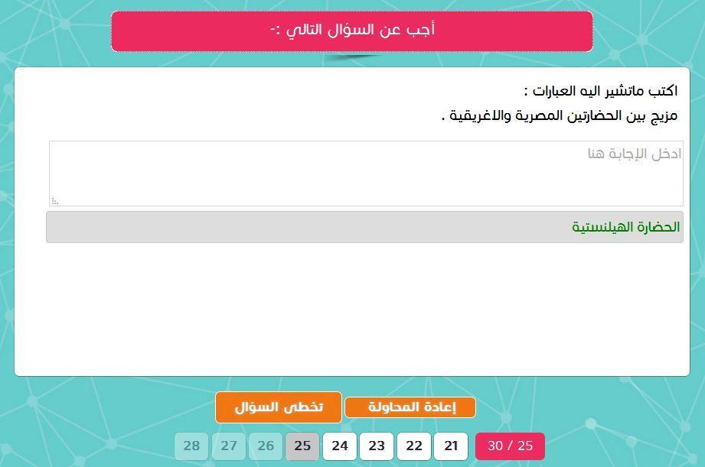

In the case was a long question and answer only one line: Question accommodates six lines and accommodate each line 10 words, the answer to accommodate one line and 10 words per line.

In case the question one line and the long answer: Question accommodate one line and only 10 words, the Answer accommodate 5 lines and accommodate 10 word per line.

In the case was a long question and answer: Question accommodate three lines in each line 10 the word, the answer accommodate 3 lines and 10 words per line.

## ***Essay questions with vertical image***

Question accommodate 2 lines and the line accommodates 7 words, the answer to accommodate 2 lines and 7 words only

Images can’t have text

## 

## 

## 

## ***Essay questions with Horizontal image***

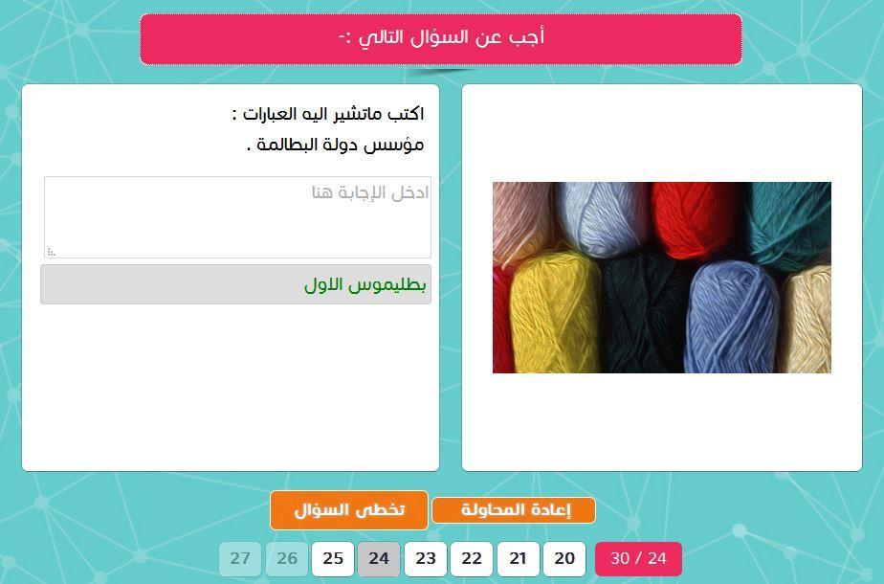

Question accommodate 2 line of max 7 words, the answer accommodate 3 Line and 7 word only

Images can have text

# ***Science Questions Templates***

## ***Slide 04- Choose***

sub title of **max 10 words 80 chars**

question text of **max 3 lines 5 words** per line

single choice option max **4 options**

Images can have text

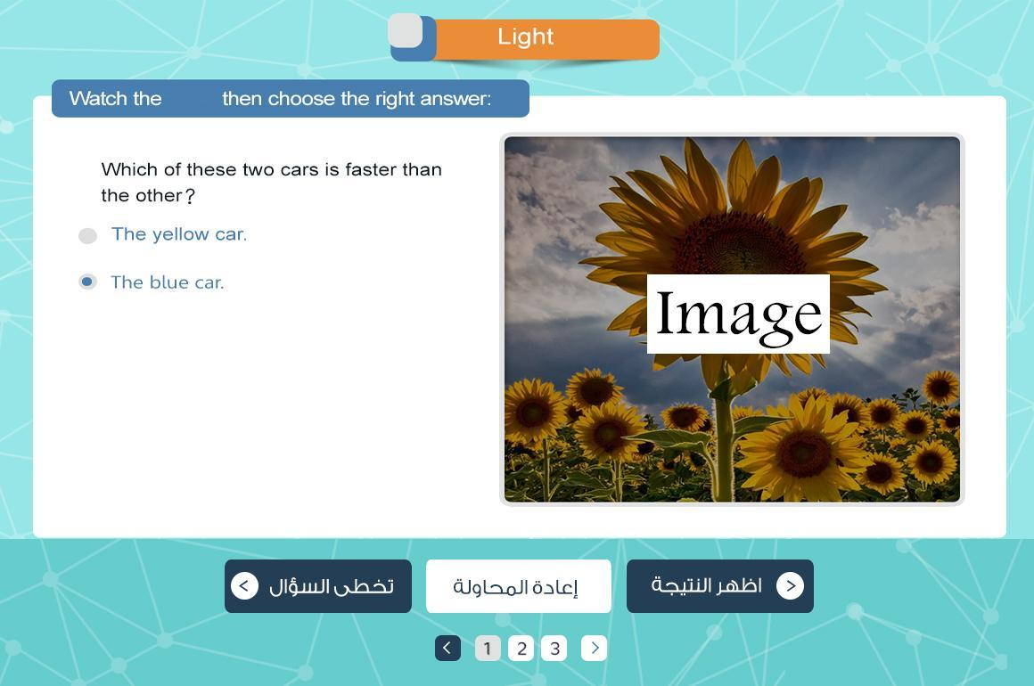

## 

## 

## ***Slide 06- Complete***

max **8 line of max 6 words** each - complete input count as 2 words -

Images can have text

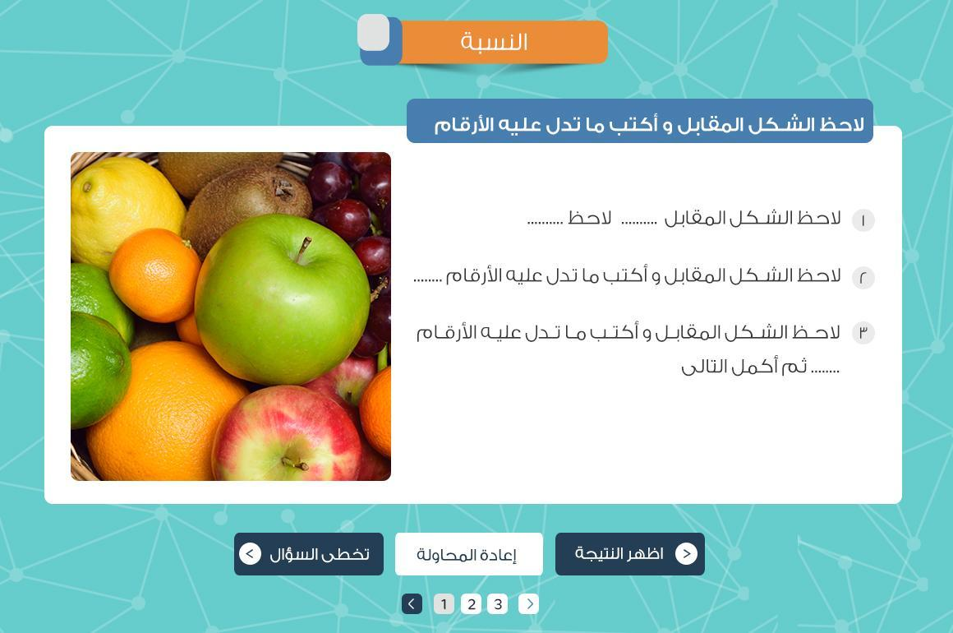

## 

## 

## ***Slide 08-Put Circle***

sub title of **max 10 words 80 chars**

max **3 lines** of max **4 nodes**

each **node** max **2 words**

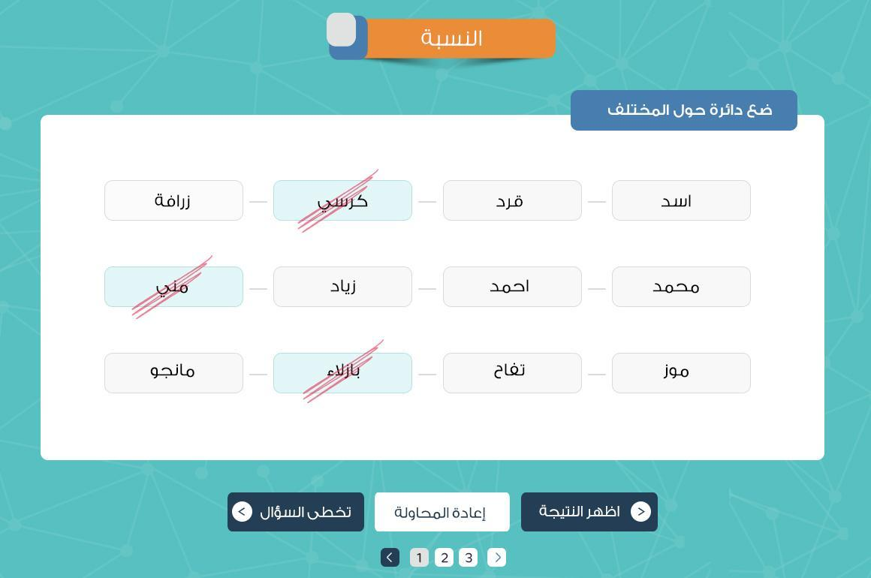

## 

## 

## ***Slide 10- Reorder images***

sub title of **max 10 words 80 chars**

max **5 images** to sort

Images can have text

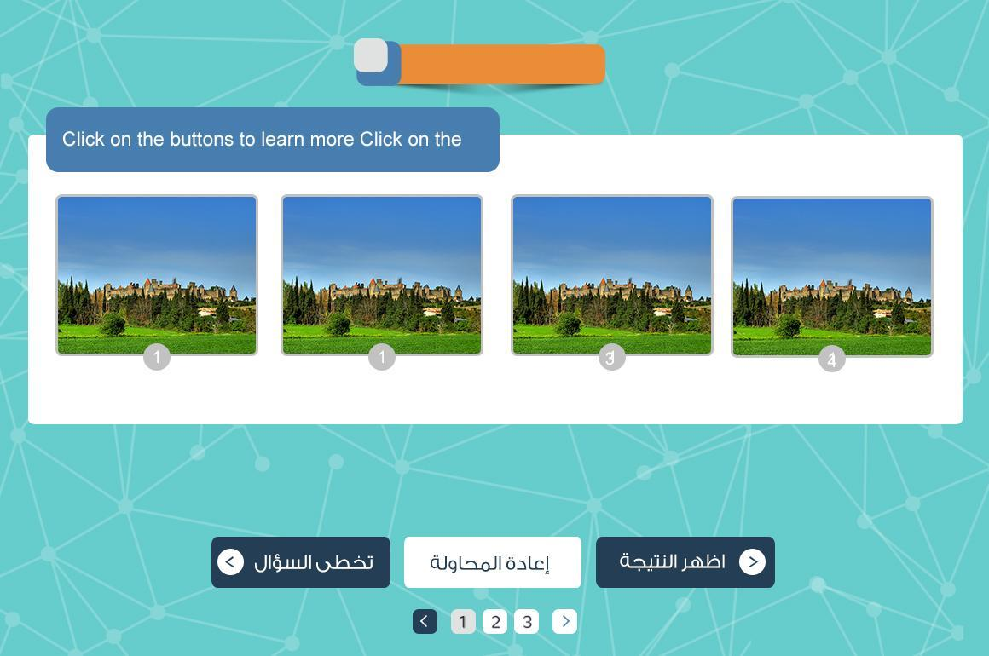

## 

## 

## ***Slide 12 - Match***

sub title of **max 10 words 80 chars**

**one to one matching**

max **5 elements** per column to match

element of **max 2 words**

Images can’t have text

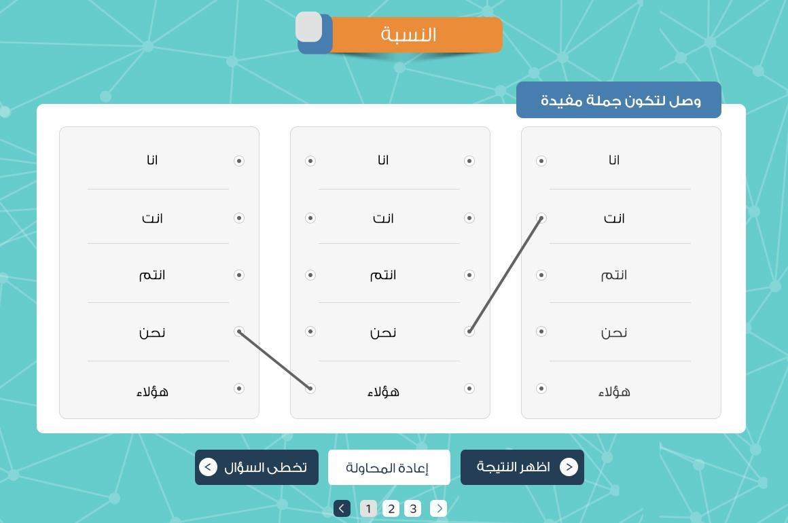

## 

## 

## ***Slide 14- drag & Drop***

sub title of **max 10 words 80 chars**

max **5 elements** to drop

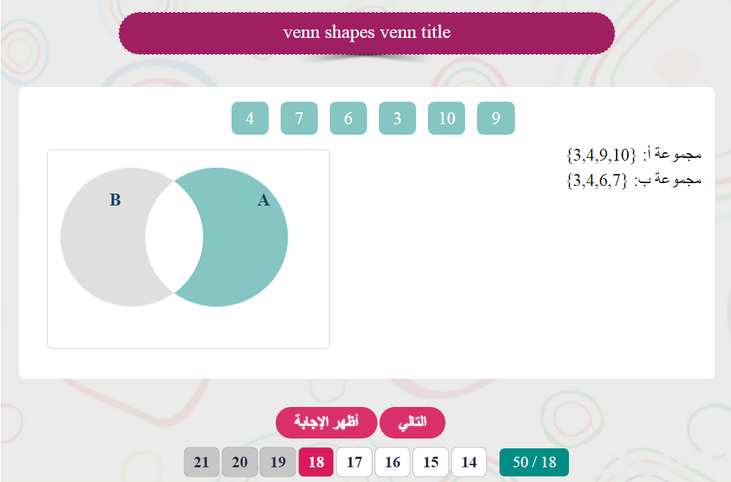

## 

## 

## ***Slide 16- Re correct***

sub title of **max 10 words 80 chars**

max **8 line of max 10 words** each - complete input count as 2 words -

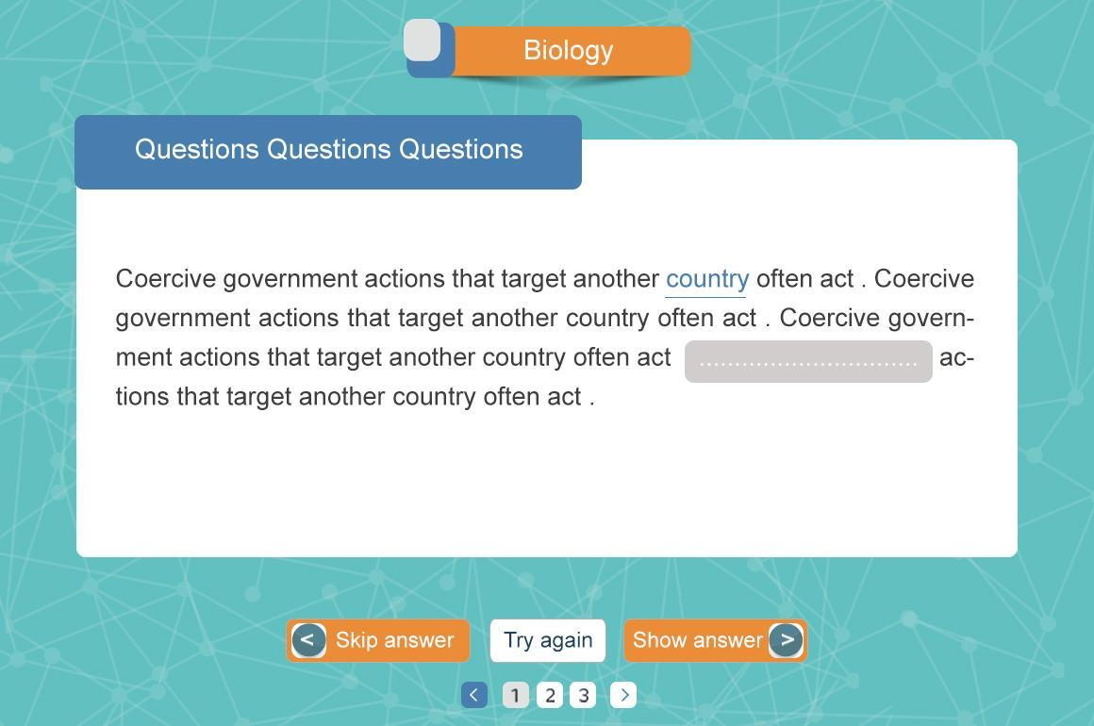

# 

# 

# ***Math Templates***

## ***Definition Slide 2***

* text - **max 9 lines , with max 5 words per line -**
* optional intro sound
* one or more images
* Images can have text

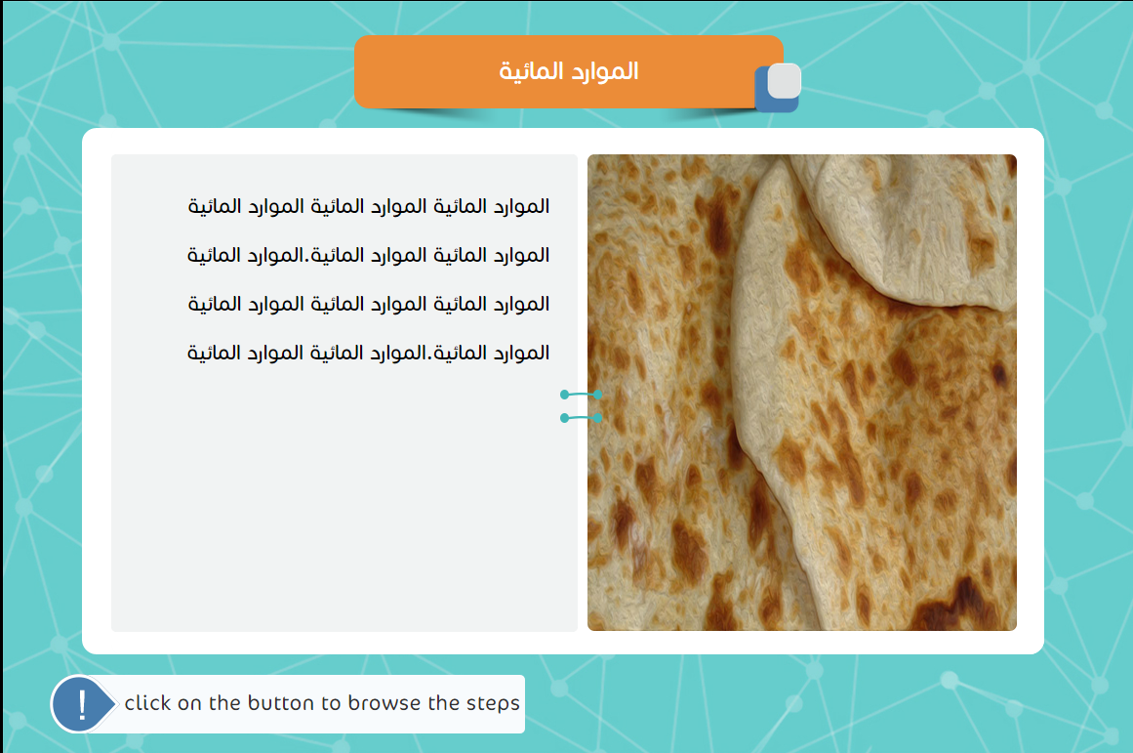

## 

## 

## ***Steps Slide 4***

* text - **max 9 lines , with max 5 words per line -**
* optional intro sound , 10 lines for intro text and 3 words with 5 characters for intro button text
* one or more images per point
* up to **5 points**
* each step has optional sound
* **Each step must have image or video**
* Images can have text

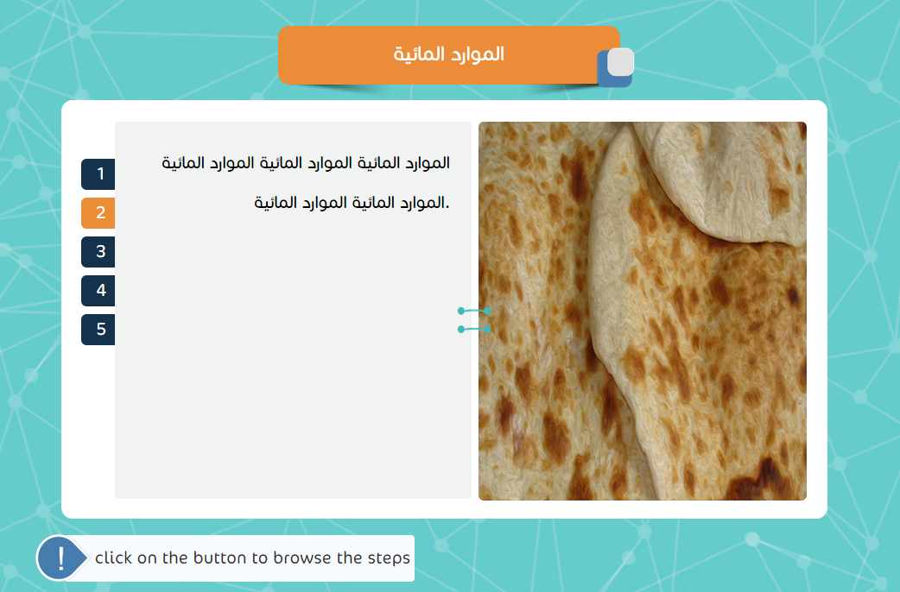

## Steps.png

## 

## ***Table Slide 6***

* from **2 row , 2 columns** up to **5 rows , 5 columns**
* text per cell **max 5 words of 40 chars**
* any cell can contain one image with no text
* Images can’t have text

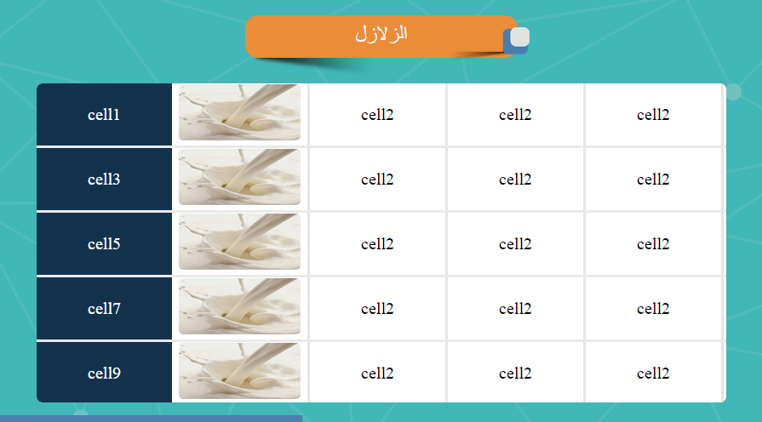

## 

## 

## ***Process circle Slide 8***

* description text of **max 2 lines 8 words per line**
* from **2 to 6 steps**
* **Arrows are optional to display**
* each step - tab , process -
  + **title only one word**
  + text of **8 lines 6 words per line**
  + at least one or more images per step
  + optional sound per step
* Images can’t have text

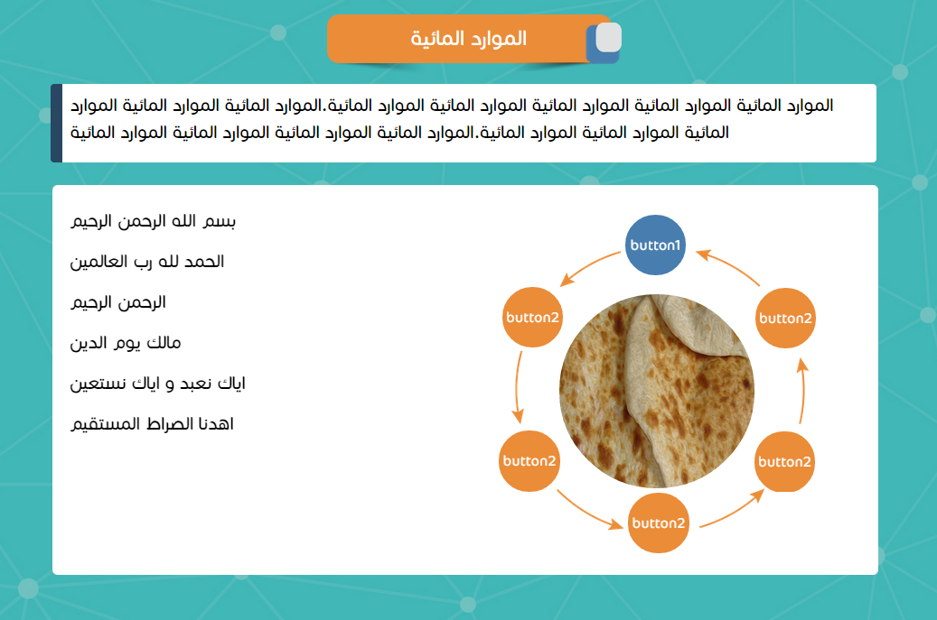

## 

## 

## ***Values Slide 10***

* **one line of max 10 words**.
* optional intro sound
* values in between one and 9 billion

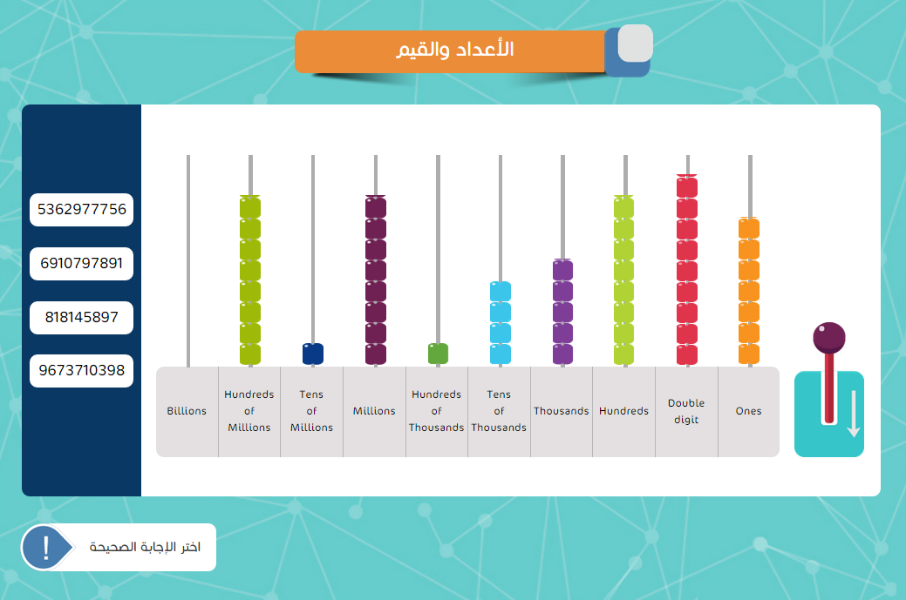

## 

## 

## ***Venn Shapes Slide 14***

* total number of elements of setis **10 elements**
* Sound of intro and end
* only **three sets** available but the third one must be contains all two other sets
* text of **max 3 line 8 words per line**
* draggable shapes are **3 shapes**
  + **two intersected sets**
  + **two aparted sets**
  + **two overlapped sets**

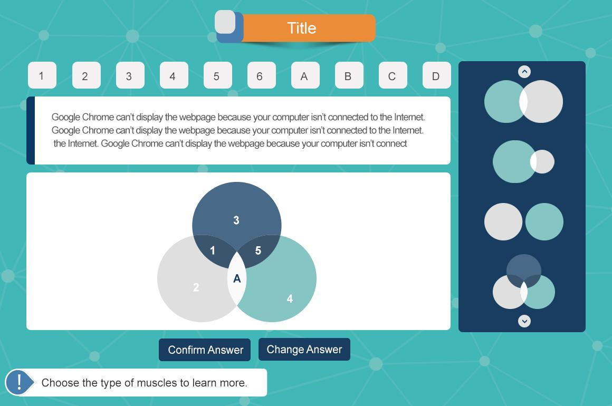

## 

## 

## **Example and Solution Slide 16**

First tab default is hidden until click prompt button

in **tab** mode can have up to **5 solutions**

in **column** mode can have only **two solutions**

each solution can have up to **3 buttons**

Images can’t have text

buttons popups

* text of **9 lines - max 5 words - text is a must**
* **media** - image[s] or video -

if example in page and solutions in another page

* example can have **one image**
* example can have text up to
  + **10 lines - max 5 words per line -** if ‘ve image -
  + **10 lines - max 10 words per line** - if no image -
* Solutions each step can have
  + text in tab : **8 lines - max 5 words per line -**
  + text in column : **3 lines - max 7 words per line -**
  + **media** - image[s] or video -

if example and solutions in same page

* example can have **one image**
* example can have text up to
  + **5 lines - max 5 words per line -** if ‘veo image -
  + **10 lines - max 5 words per line** - if no image -
* Solutions each step can have
  + text in tab : **8 lines - max 3 words per line -**
  + text in column : **3 lines - max 5 words per line -**
  + **media** - image[s] or video -

**Single page mode**

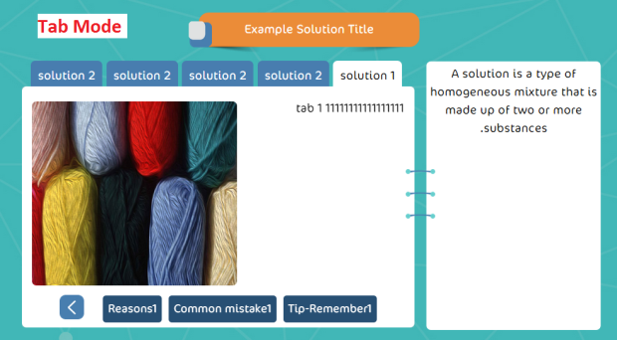 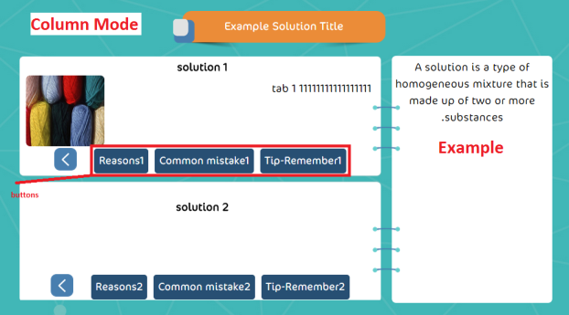

**Two page mode**

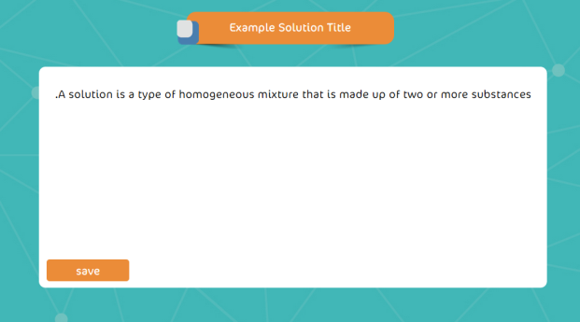 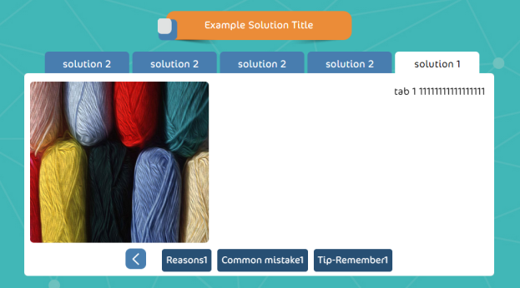

## 

## 

## ***Notes Slide 29***

* title of max **4 words of 30 chars**
* text of **max 9 lines 6 words per line**
* **no sound**
* up to **10 notes**

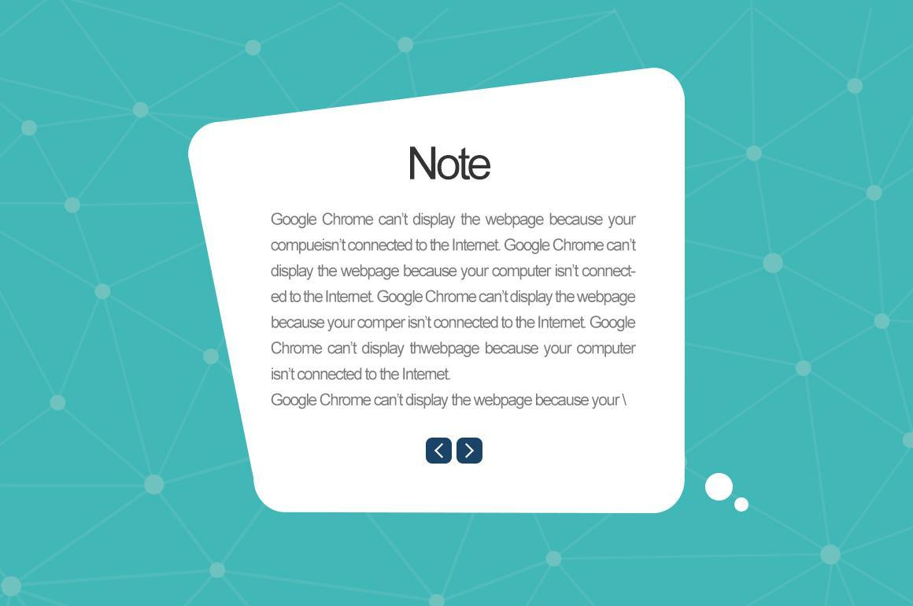

## 

## 

## ***Math Flow Chart Slide 42***

* sub title
  + from **2 to 5**
  + of max **3 words**
* under each title
  + text of **8 lines 5 words per line [must]**
  + media section [must]
    - one or more images
    - or video
  + optional sound per title
* **optional intro sound**
* **popup text of max 8 lines - max of 8 word per line.**
* **Popup Sound pulse images or Video**
* Images can have text

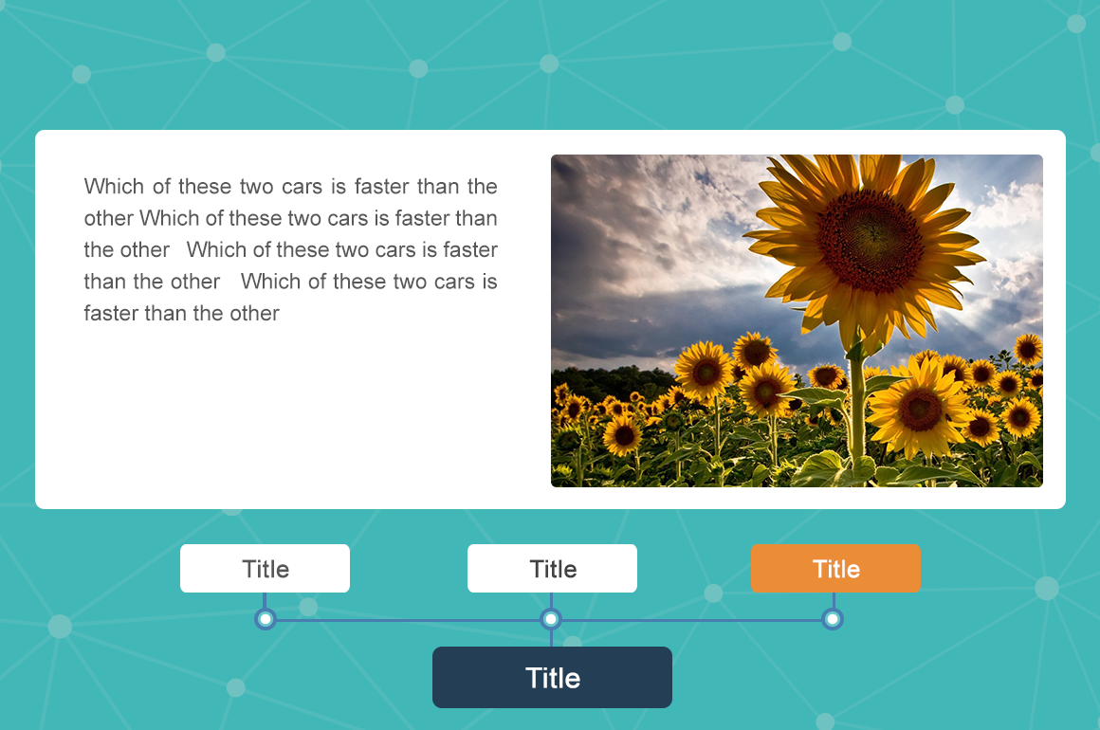

## 

## 

## ***Theory 1 Slide 44***

* definition title of **max 3 words**
* definition text of **max 3 lines 6 words per line**
* text of **8 lines 5 words per line**
* one or more images
* optional intro sound
* Images can’t have text

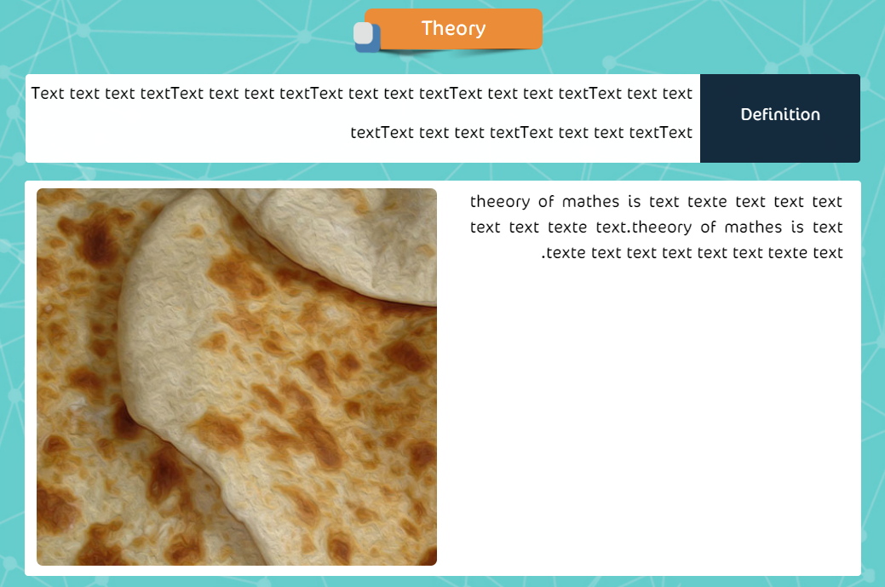

## 

## 

## ***Theory 2 Slide 46***

* definition title of **max 3 words**
* definition text of **max 3 lines 6 words per line**
* up to **5 tabs** each
  + text of **5 lines 8 words per line -** for more scroll will appear
  + no images
  + optional sound per tab
* optional intro sound

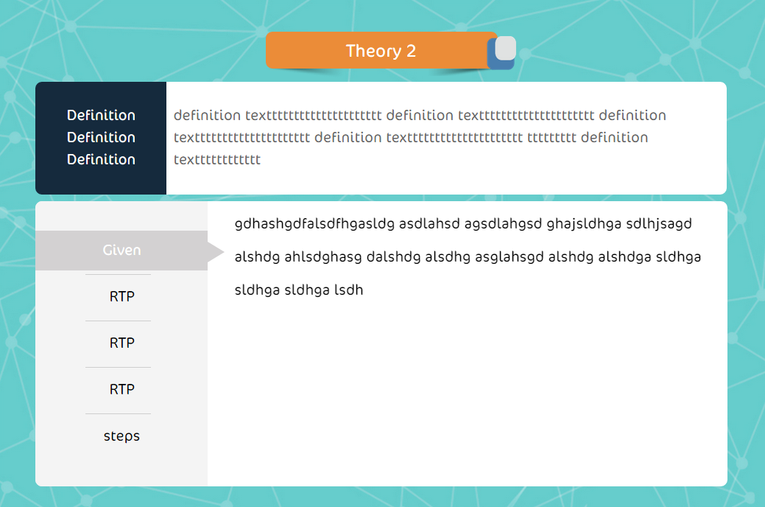

## 

## 

## ***Maze 2 Slide 22 from quiz to activity***

* maze **must be 22 nodes**
* one each branch operation lead to next node
* **min 5 operations**
* if user select the wrong node feedback will show
* user can **only continue with right path**
* optional intro and final sound

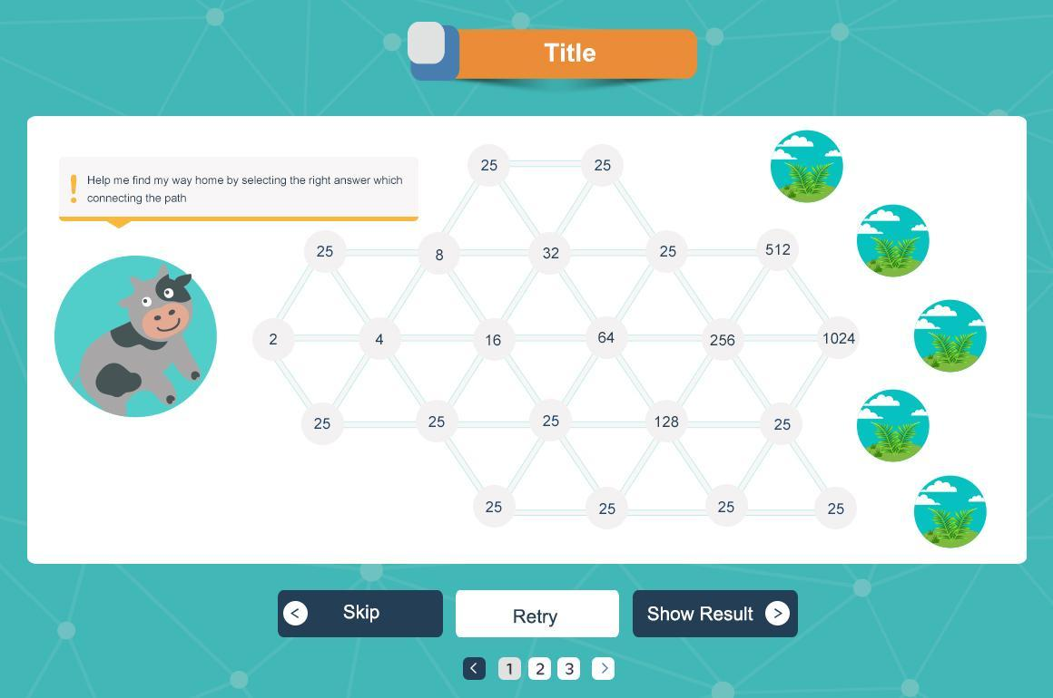

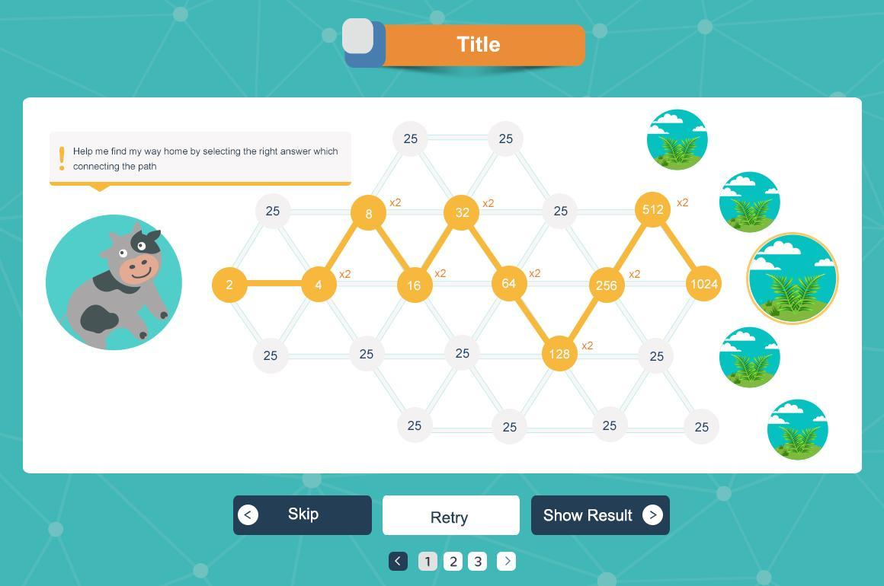

## 

## 

## ***Proof Slide 24 from quiz to activity***

* question text of **max 5 lines 10 words per line**
* optional intro sound
* only **complete** question if **max 3 inputs**
* steps page
  + text of **8 lines 5 words per line**
  + one or more images
  + optional sound
* Images can have text

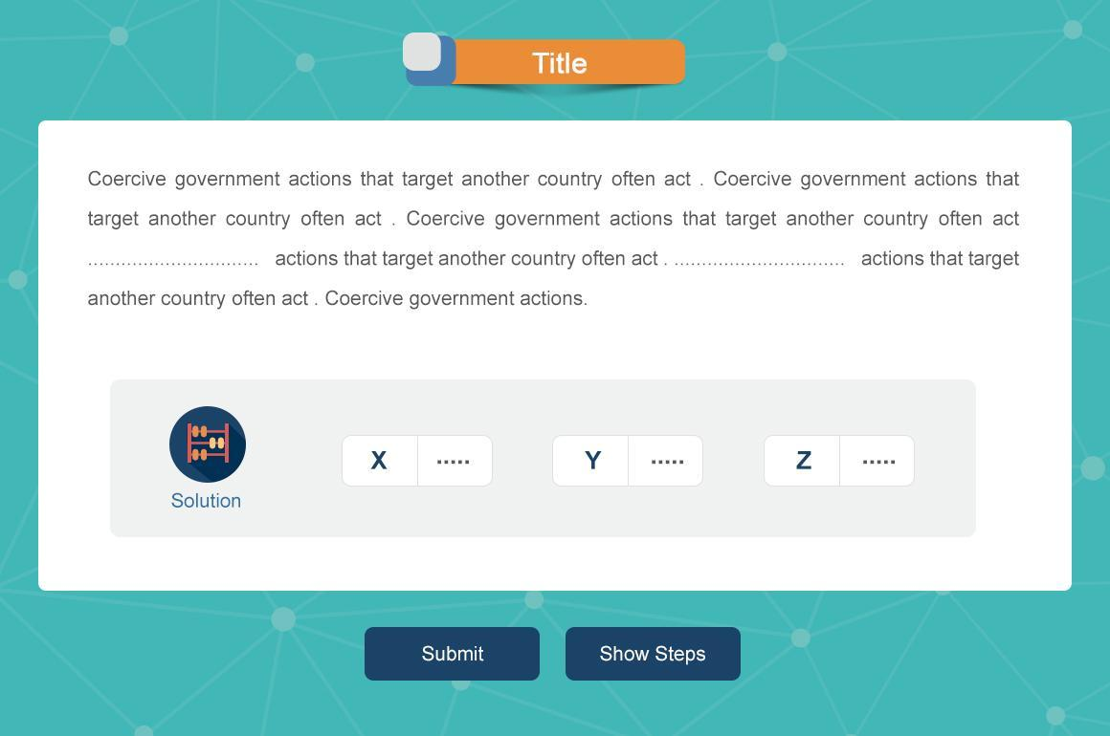

## page 22 popup.jpg

## ***Math Chart Slide 34 from quiz to activity***

* question text of **max 7 lines 0f max 10 words per line**
* table two rows of **max 8 points**
* scale will always be in **5 points** - x,y axis will be scaled to 5 points in **positive direction** -

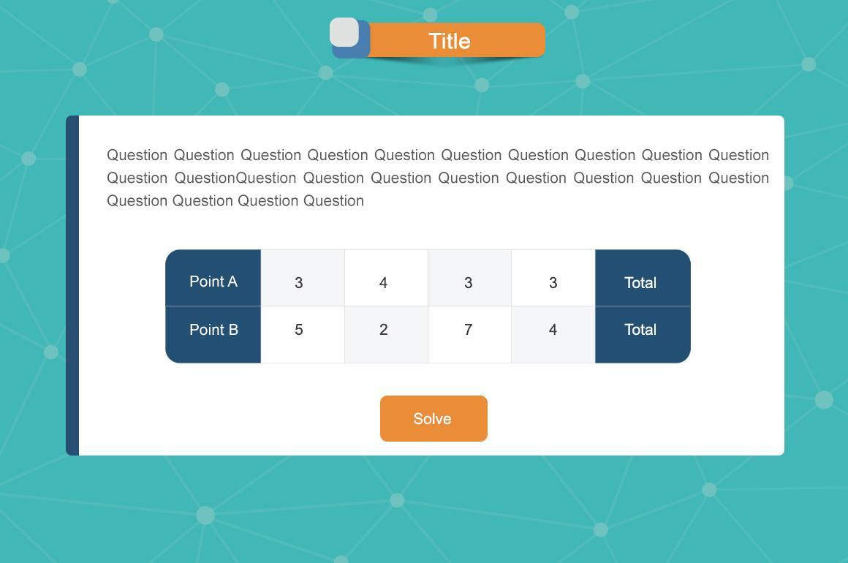

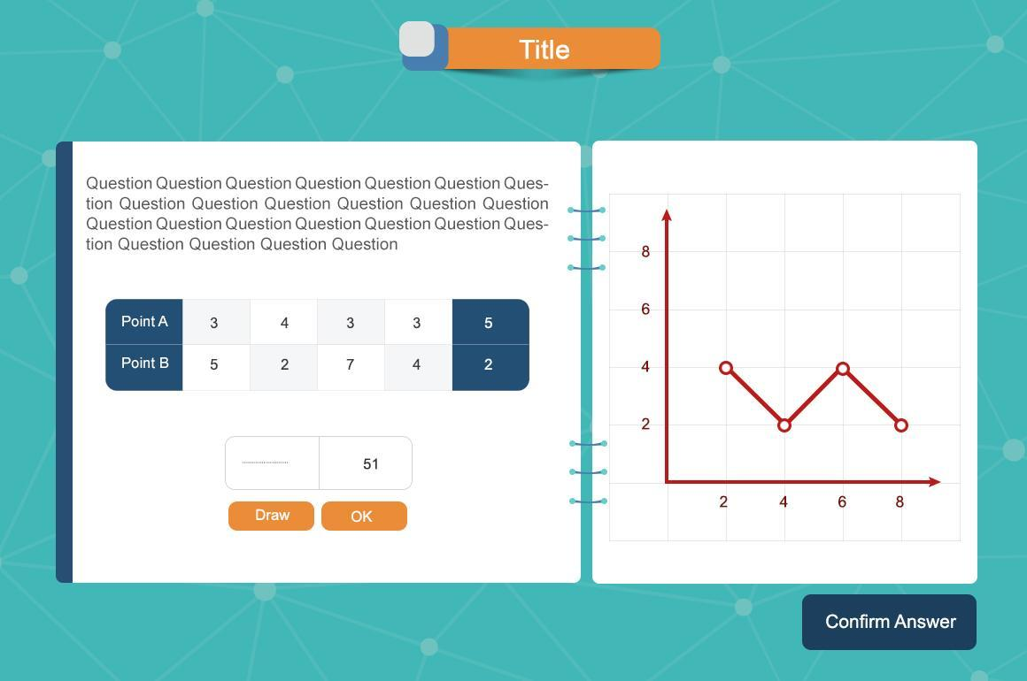

***Drawing***

**عنوان الشاشة حتى 7 كلمات**

**نص السؤال يدعم عدد سطرين فى كل سطر حتى 10 كلمات**

**يمكن اضافة عدد سطر اضافية حتى 3 سطور اضافية فى صورة accordion**

**مراعاه ان صورة اظهار الاجابه حجمها 900*410 px**

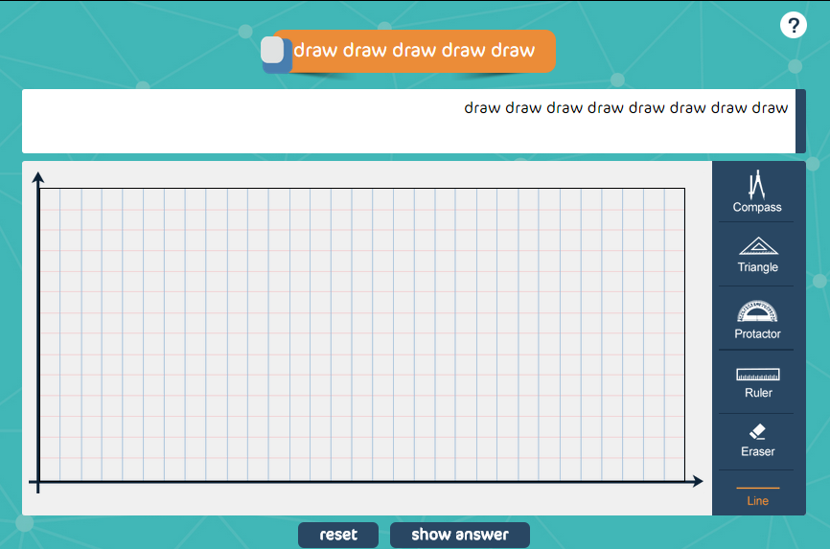

***Math Quiz Specification***

Math questions templates slide2

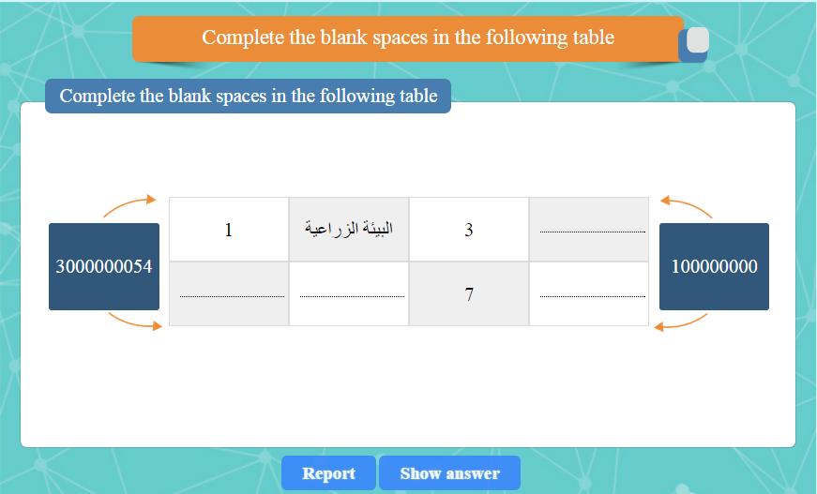

Math questions templates slide4

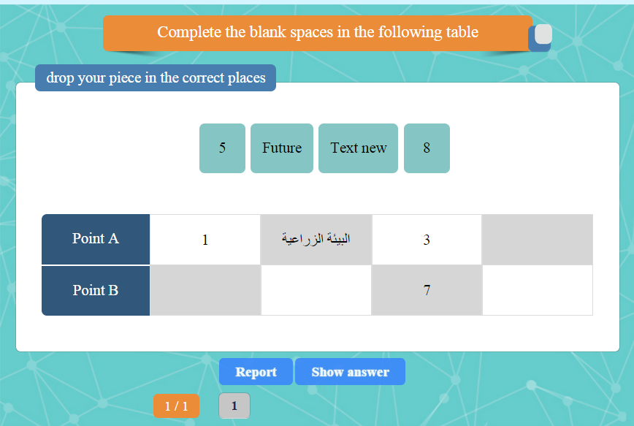

1 - Must Have Question Address (From 3 to 7 Words Max)

2 – Must Have Question Text (From 3 to 7 Words Max)

3 – Have 2 Value at the Side of the Table and Can Be (up to 7 digit Max) OR Max (2 Words)

4 – Values of the Table can be Words but It Must be (From 1 to 2 Words Max)

5 - Table of max 4 columns and one title - title is a must- , of max 2 rows

6 - Draggable elements up to 5 max.

**Venn Question**

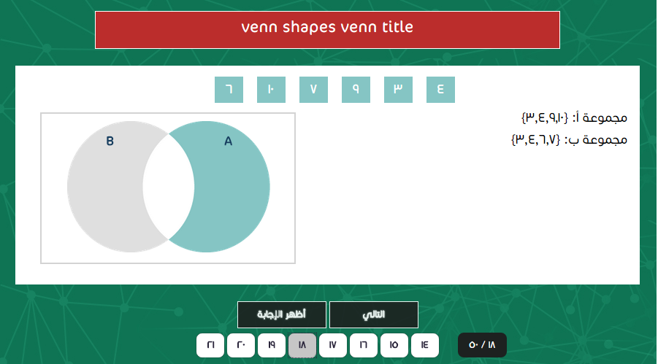

* total number of elements of setis **8 elements**
* only **two sets** available
* text of **max 3 line 8 words per line**
* draggable shapes are **3 shapes**
  + **two intersected sets**
  + **two aparted sets**
  + **two overlapped sets**

**Horizontal Match:** Math questions templates slide6

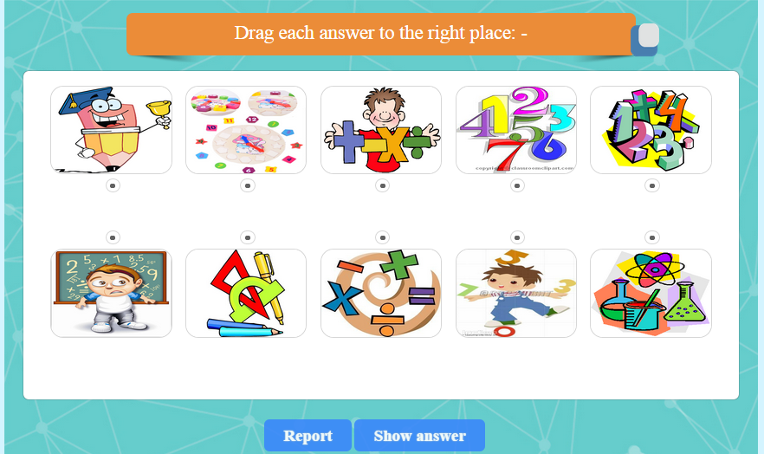

1 - Must Have Question Address (From 3 to 7 Words Max)

2 – Must be 2 Rows and max of 5 Cell Max – 4 words each -

Images can’t have text

**Vertical Match**

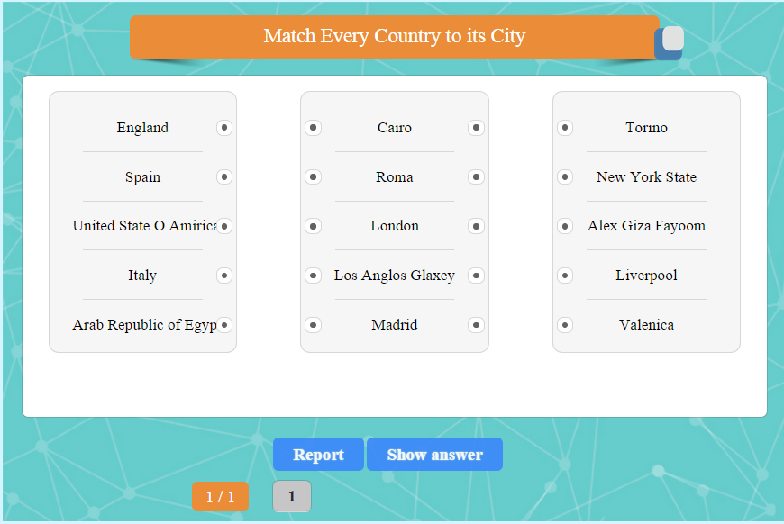

1 - Must Have Question Address (From 3 to 7 Words Max)

2 – May Have 2 or 3 columns and Have up to 5 Cell In Each Column

3 – Each Cell Have Max 3 Words in 3 columns and 4 words in 2 columns

**Complete TimeLine:** Math questions templates slide10

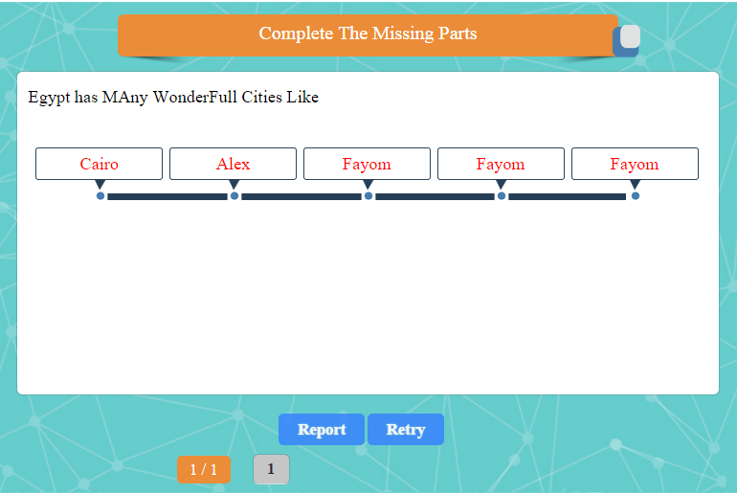

1 - Must Have Question Address (From 3 to 7 Words Max)

2 – Answer can be From 3 To 5 Max

3 – Answer can be From 1 To 2 Words

4 – question text up to 5 lines – of max 8 words per line -

**Complete Drag & Drop Question:** Math questions templates slide 12 , 30

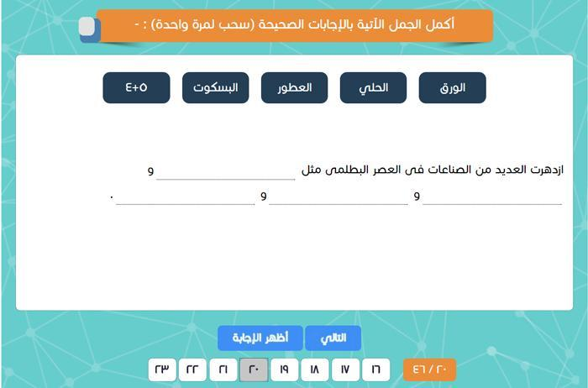

1 - Must Have Question Address (From 3 to 7 Words Max)

2 – Can have from 3 to 8 draggable elements – each of max 2 words -

3 – Question text can have up to 4 lines – each of max 8 words and input count as 3 words -

**4 - if a vertical image**

a - max 4 draggable elements – each of max 2 words -

b - Question text can have up to 4 lines – each of max 4 words and input count as 3 words -

**Values Question**

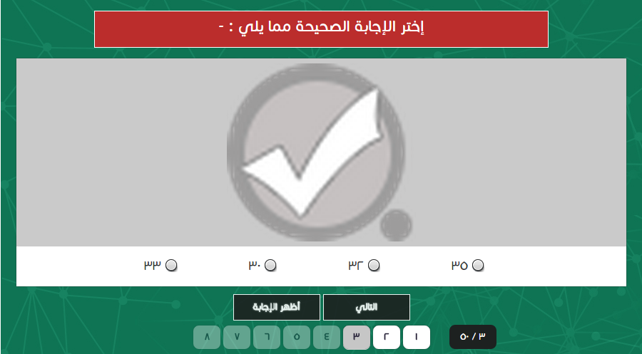

**only one image**

**up to 4 choices - total count of words in all choices max 10 words -**

Images can have text

**Drag and drop question**

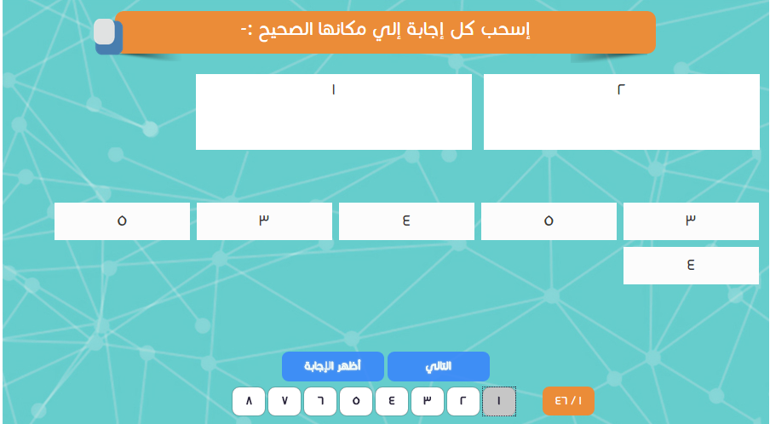

**max of 2 drawable group each of max 3 words**

**max of 6 draggable elements each of max 2 words**

**Highlight questions** Math questions templates slide 18

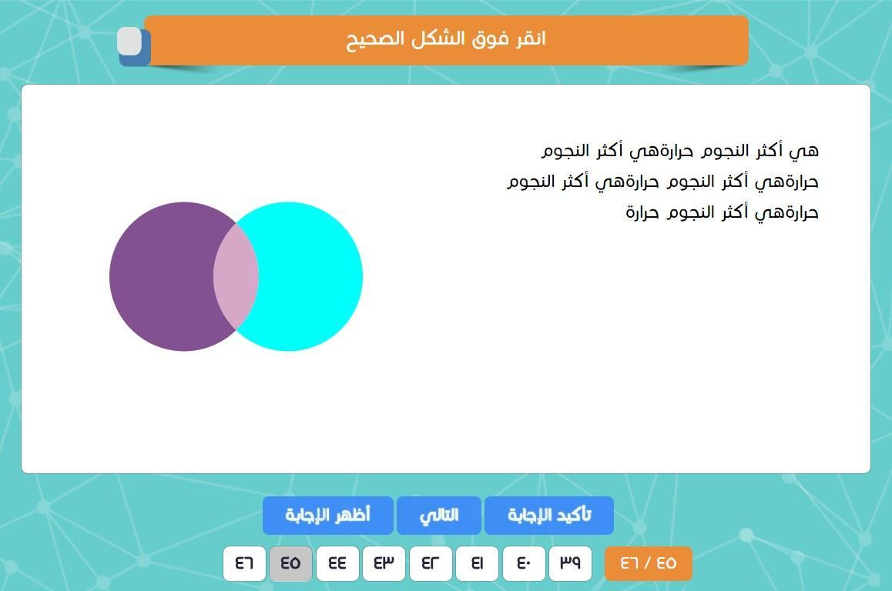

1. Question text up to 7 lines of max 5 words per line
2. Answer shape should have a clear uniform shapes

**Choose From Pic:** Math questions templates slide 24

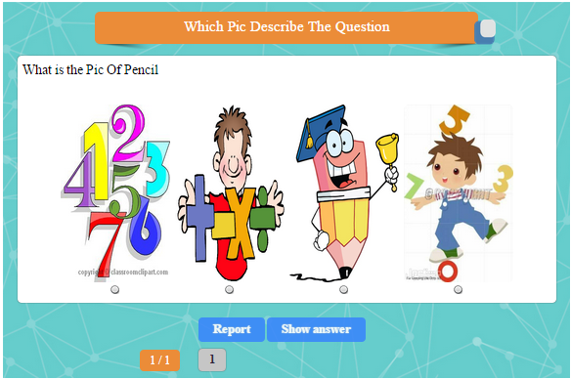

1 - Must Have Question Address (From 3 to 7 Words Max)

2 – Answer Must Be 4 Pic Only

**3 - question text one line of max 10 words**

Images can’t have text

**Friction Question** Math questions templates slide 26, 28

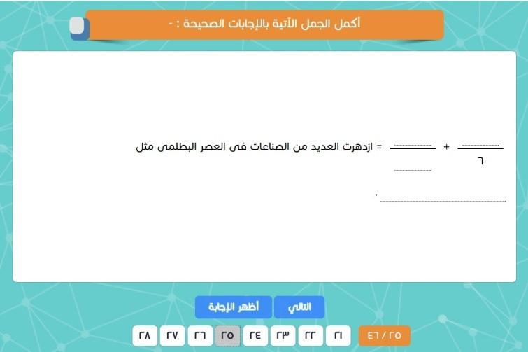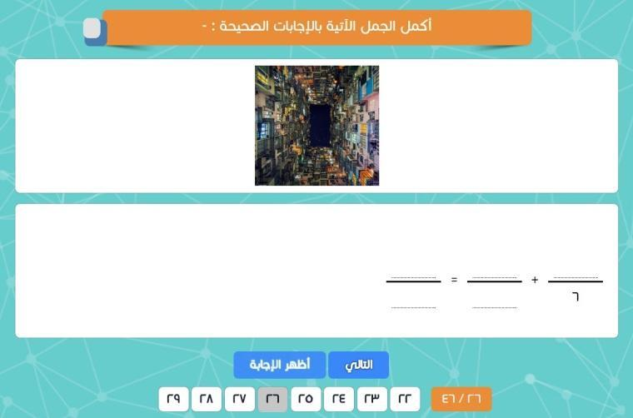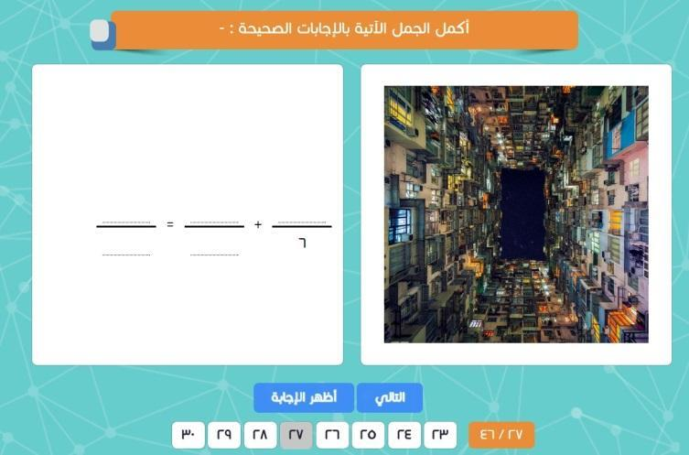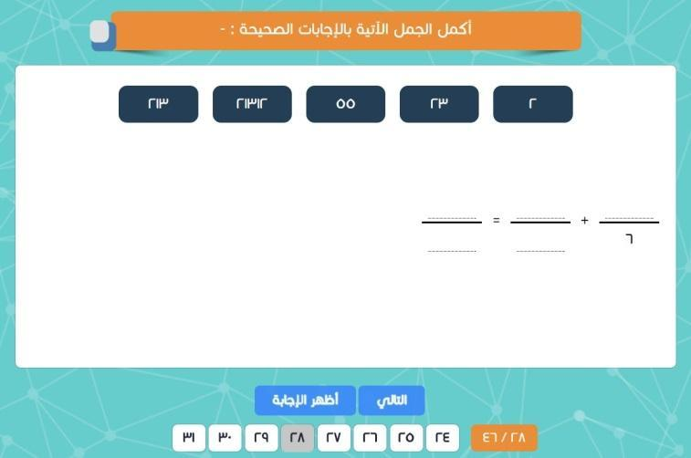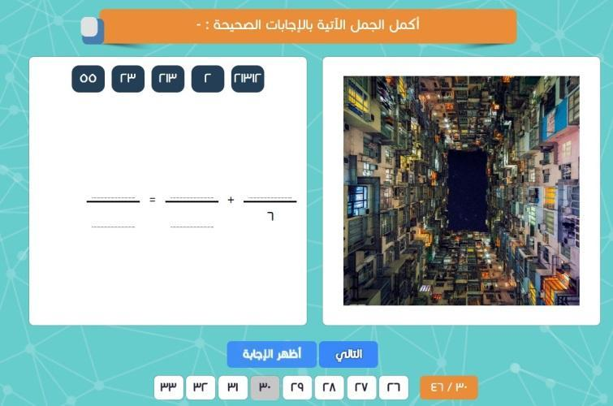

All forms of complete question can have friction in it but these set some rules on each type

**Normal view ( screen 1)**

question text up to 2 lines – of max 8 words , input count as 3 words

if draggable Can have from 3 to 8 draggable elements – each of max 2 words -

**Hor. image ( screen 2,4)**

question text 1 lines – of max 8 words , input count as 3 words –

**Ver. image ( screen 3,5)**

question text up to 2 lines – of max 4 words , input count as 3 words , **max 3 fraction per line without any words in between** –

if draggable Can have up to 4 draggable elements – each of max 2 words -

**and one line if fraction appear -of max 4 words , input count as 3 words , max 3 fraction per line without any words in between –**

**No fraction Drag & Drop in Hor. Image.**

**Complete series** Math questions templates slide 32

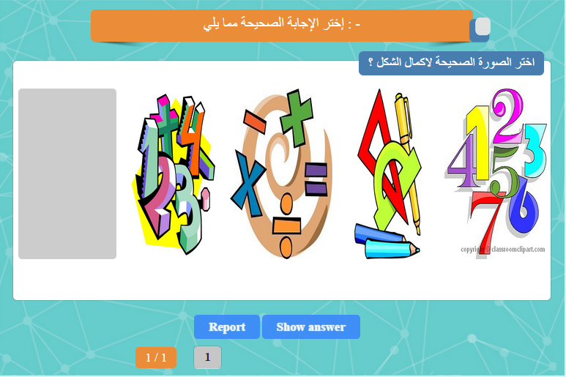

1 - Must Have Question Address (From 3 to 7 Words Max)

2 – Answer Must Be 4 Pic Only

3 – Question Must be from 2 to 4 pic and Empty Space For Answer

Images can have text